|  |  |  |  |  |
| --- | --- | --- | --- | --- |
|  |  | | |  |
|  |  | | |  |
|  | Ambient Lighting (CX821/CX771)  <<Feature>>  (F00063) | | |  |
|  |  | | |  |
| Document Type | **Feature Document (FD)** | | |  |
| Template Version | **6.1b** | | |  |
| SysML Report Template Version | **6.1b.6** | | |  |
| Document ID | **featuredocument_sysmlreport_6.1b.6.docx** | | |  |
| Document Location |  | | |  |
| Document Owner | Ouyang Jun; Joss Yin | | |  |
| Document Revision | **FD1** | | |  |
| Document Status | **Draft** | | |  |
| Date Issued | **2022/08/18** | | |  |
| Date Revised | **2022/08/18** | | |  |
| Model Name and Version | **Ambient lighting – [#782]** | | |  |
| Document Classification | GIS1 Item Number: | **27.60/35** | |  |
| GIS2 Classification: | **Confidential** | |
|  | | | | |
|  | | | | |
| Document Approval | | | | |
| Person | Role | | Email Confirmation | Date |
|  |  | |  |  |
|  |  | |  |  |

**Auto-Generated by MagicDraw**

Printed Copies Are Uncontrolled

# Disclaimer

**This document contains Ford Motor Company Confidential information. Disclosure of the information contained in any portion of this document is not permitted without the expressed, written consent of a duly authorized representative of Ford Motor Company, Dearborn, Michigan, U.S.A.**

**Copyright, Ó 2021 Ford Motor Company**

This document contains information developed and accumulated by and for FORD MOTOR COMPANY. As such, it is a proprietary document, which, if disseminated to unauthorized persons, would provide others with restricted information, data, or procedures not otherwise available, exposing the FORD MOTOR COMPANY to potential harm.

Employees and suppliers having custody of this specification or authorized to use it must be cognizant of its proprietary nature and ensure that the information herein is not made available to unauthorized persons.

FORD MOTOR COMPANY reserves the right to protect this work as an unpublished copyrighted work in the event of an inadvertent or deliberate unauthorized publication. FORD MOTOR COMPANY also reserves its rights under copyright laws to protect this work as a published work.

This document or portions thereof shall not be distributed outside FORD MOTOR COMPANY without prior written consent. Refer all questions concerning disclosure to the author(s) or to any duly authorized representative of Ford Motor Company.

**Copyright** © **2021 Ford Motor Company**

# Contents

Disclaimer 21

Contents 22

1 Introduction 25

1.1 Document Purpose 25

1.2 Document Scope 25

1.3 Document Audience 25

1.3.1 Stakeholder List 25

1.4 Document Organization 26

1.4.1 Document Context 26

1.4.2 Document Structure 26

1.5 Document Conventions 27

1.5.1 Classification of Chapters 27

1.5.2 Requirements Templates 27

1.6 References 27

1.6.1 Ford Documents 27

1.6.2 External Documents and Publications 28

1.7 Glossary 28

1.7.1 Definitions 28

1.7.2 Abbreviations 28

1.7.3 Parameters / Values 28

2 Feature Overview 30

2.1 Purpose and Description of Feature 30

2.2 Feature Variants 30

2.2.1 Regions & Markets 31

2.3 Input Requirements/Documents 32

2.4 Lessons Learned 33

2.5 Assumptions 34

3 Feature Context 35

3.1 Feature Context Diagram 35

3.2 List of Influences 35

4 Feature Modeling 37

4.1 Operation Modes and States 37

4.2 Use Cases 41

4.2.1 Use Case Diagram 41

4.2.2 Actors 41

4.2.3 Use Case Descriptions 42

4.3 Driving and Operation Scenarios 47

4.4 Decision Tables 50

5 Feature Requirements 51

5.1 Functional Requirements 52

5.1.1 Error Handling 52

5.2 Non-Functional Requirements 52

5.2.1 Safety 52

5.2.2 Security 52

5.2.3 Reliability 53

5.2.4 Performance 53

5.3 HMI Requirements 53

5.4 Other Requirements 53

5.4.1 Design Requirements 53

5.4.2 Manufacturing Requirements 54

5.4.3 Service Requirements 54

5.4.4 After Sales Requirements 54

5.4.5 Process Requirements 55

5.4.6 Uncategorized Requirements 55

6 Functional Safety 56

6.1 System Behaviors for HARA 56

6.2 Functional Safety Assumptions 56

6.3 Safety Goals 57

6.4 Functional Safety Requirements 59

6.4.1 Safety Goal: 60

6.4.2 Derivation of Functional Safety Requirements on Assumptions 62

6.4.3 ASIL Decomposition of Functional Safety Requirements 62

7 CyberSecurity 64

7.1 Security Goals 64

7.2 Cybersecurity Requirements 65

8 Architecture 66

8.1 Functional Decomposition 66

8.1.1 Functions 67

8.2 Logical Architecture 68

8.2.1 Logical Elements 68

8.2.2 Logical Interfaces 69

9 Traceability Matrix 71

10 Open Concerns 72

11 Revision History 73

12 Appendix 74

12.1 Definitions 74

12.2 Abbreviations 74

**List of Figures**

Figure 1. 13

Figure 2: 30

Figure 3: - 30

Figure 4: 35

Figure 5: 37

Figure 6: 41

Figure 7: 48

Figure 8: 48

Figure 9:  61

Figure 10: 66

Figure 11: 68

**List of Tables**

Table 1: Features described in this FD 25

Table 2: Stakeholder’s list 26

Table 3: Ford internal Documents 28

Table 4: External documents and publications 28

Table 5: Parameters / Values used in this document 29

Table 6: Feature Variants 31

Table 7: Regions & Markets 32

Table 8: Input Requirements/Documents 33

Table 9: List of Influences 36

Table 10: Operation Modes and States on 38

Table 11: Transitions between Operation Modes and States on 41

Table 12: List of Actors 42

**Table 13:**  50

Table 14: System Behaviors for HARA 56

Table 15: Functional Safety Assumptions 57

Table 16: Functional Safety Goals 59

Table 17: Cybersecurity Goals 64

Table 18: List of Functions 67

Table 19: List of Functions on 68

Table 20: Logical Elements 69

Table 21: Feature Interactions 70

Table 22: Feature Interactions on 70

Table 23: Open Concerns *(Not supported by MagicDraw report generation)* 72

Table 24: Revision History 73

Table 25: Definitions used in this document 74

Table 26: Abbreviations used in this document 75

# Introduction

## Document Purpose

A Feature Document (FD) document defines a Feature on [Concept Level](https://bd101001.pd2.ford.com/stages/#/workspace/209/_vv/(process/activity/_Y6ftAPI2VsW5zd82DgHb6g)). It specifies **what** the feature shall do and how it shall behave from customer perspective. It should also provide reasoning and background **why** we have the feature in the vehicle.

The FD also serves as an Item Definition as defined by ISO26262 for those features, which follow the Ford Functional Safety process. Refer [FFSG01.10 Feature Document Guideline](https://azureford.sharepoint.com/sites/GlobalFunctionalSafety/Released%20Templates%20Guidelines%20and%20Examples/Guidelines/FFSG01.10_FeatureDocument_Guideline.pdf) for how to apply the Feature Doc template for Functional Safety.

## Document Scope

This Feature Document (FD) specifies the following features:

| **Feature ID** | **Feature Name** | **Owner** | **Reference** |
| --- | --- | --- | --- |
| F00063 | Ambient Lighting (CX821/CX771)  (Program(s): CX821  CX771  ) | Ouyang Jun; Joss Yin |  |

Table 1: Features described in this FD

## Document Audience

The FD is written by the feature owner of Ambient Lighting (CX821/CX771). All Stakeholders, i.e., all people who have a valid interest in the feature should read and, if possible, review the FD. It needs to be guaranteed, that all stakeholders have access to the currently valid version of the FD.

### Stakeholder List

For the latest list of stakeholder of the feature and their influence refer to: [Click here to open the latest Stakeholders List.](https://azureford.sharepoint.com/sites/FordALCM/Shared%20Documents/Forms/AllItems.aspx?id=%2Fsites%2FFordALCM%2FShared%20Documents%2FAmbientLightingSpec%2FStakeHolder&viewid=354af59c%2D41cd%2D4773%2Db954%2D9dd976f14bfa)

## Document Organization

### Document Context

Refer to the [Specification Structure page](http://wiki.ford.com/display/RequirementsEngineering/Specification+templates) in the [Ford RE Wiki](http://wiki.ford.com/display/RequirementsEngineering/Requirements+Engineering+for+SW+Enabled+Features) to understand how the FD relates to other Ford Requirements Documents and Specifications.

### Document Structure

The structure of this document is explained below:

**Introduction** – Explains how to use this document including responsibilities and requisite documents. Explains the terminology. Gives a clarification of the definitions, concepts and abbreviations used in the document.

**Feature Overview** – States briefly the background and the purpose of the feature, feature variants and corresponding regions and markets. Also includes input requirements, assumptions, and constraints.

**Feature Context** – Describes all external entities, which have an influence on the feature.

**Feature Modeling** – Contains Use Case, Driving Scenarios, State Charts to describe the functional behavior of the feature.

**Feature Requirements** – Lists functional and non-functional requirements of the feature.

**Functional Safety** – Lists System Behaviors, Safety Goals and Safety Requirements of the feature.

**CyberSecurity** – Lists Security Goals and Security Requirements of the feature.

**Architecture** – Shows the coarse architecture, which the feature requirements are deployed to. Describes the elements and the boundary of the feature as well as the decomposition and distribution of associated functions.

**Traceability Matrix** – Traceability Matrix.

**Open Concerns** – List of Open Concerns

**Revision History** – Document Change History including a list of new or modified requirements. The requirements in this document are tagged, and this section contains different types of tables listing all, new, or changed requirements by their title and page no.

**Appendix** – Appendix

## Document Conventions

### Classification of Chapters

A chapter is considered mandatory, unless the chapter or its parent chapter(s) are categorized by using the tag:

**#Classification:** Some Condition

If no requirement/other content is known for a mandatory chapter, leave a statement “Not Applicable”

Some chapters have a follow certain rules in context of specific Ford processes, e.g. Functional Safety. This is indicated at the beginning of the corresponding chapter by the tags:

**#Functional Safety:** Some process specific explanation

**#Cybersecurity:** Some process specific explanation

### Requirements Templates

Refer to “[How to use the Specification Templates](http://wiki.ford.com/display/RequirementsEngineering/How+to+use+the+Specification+Templates?src=contextnavpagetreemode)” on how to use the specification templates and the VBA macros to create/edit the requirements in the specifications.

#### **Requirements Attributes**

The templates provided by *Specification_Macros.dotm* define a list of attributes for each requirement. This helps to classify the requirement. The attributes are explained at [RE Wiki - Requirements Attributes](http://wiki.ford.com/display/RequirementsEngineering/Requirements+Attributes?src=contextnavpagetreemode).

## References

### Ford Documents

List here all Ford internal documents, which are directly related to the feature.

| **Reference** | **Title** | **Doc. ID** | **Document Location** | **Revision** |
| --- | --- | --- | --- | --- |
| ClearExitAssist | Feature Document ClearExitAssist |  |  |  |
| Custom Drive Mode Feature AFS | Custom Drive Mode (CDM) Aggregated Feature Specification V0.9.1 |  |  |  |
| Doors Off_AFS | Doors Off Aggregated Feature Specification |  |  |  |
| DriverIDFeatureSpecification | DriverIDFeatureSpecificationV1.13 |  |  |  |
| Feature Document Ambient Lighting | Ambient Lighting Feature Document V1.2 |  |  |  |
| Feature Document Turn Indicator | Feature Document Turn Indicator |  |  |  |
| Functional Specification Body Control Module | BCM Functional Specification | FS-PU5T-14B476-AGB003 |  |  |
| HMI Spec - APIM | VEHICLE SETTINGS APIM SPSS V1.23 | VSv2-FUN-REQ-025223 |  |  |
| Lincoln Embrace | Lincoln Embrace / Ford Welcome-Farewell Feature Specification_v2.2.2_CDX707 |  |  |  |
| Low Voltage Device Charging_Core_Boundary Diagram | Low Voltage Device Charging_Core_Boundary Diagram C C Variant |  |  |  |
| Navigation APIM SPSS | Feature – Navigation APIM Infotainment Subsystem Part Specific Specification (SPSS) |  |  |  |

Table 3: Ford internal Documents

### External Documents and Publications

The list of external documents could include books, reports and online sources.

| **Reference** | **Document / Publication** | **Document Location** |
| --- | --- | --- |
| Air Condition Spec |  |  |
| APIM SPSS on Incoming Call |  |  |
| APIM SPSS on Voice Control |  |  |
| Enhanced Memory | Feature Document F000172 |  |
| IEEE Std 1012-2004 IEEE Standard for Software Verification and Validation |  |  |
| ISO/IEC 19500-2:2003 | Information technology -- Open Distributed Processing -- Part 2 |  |
| Relax Mode | Feature Document F004131 |  |
| Selectable Drive Mode | Feature Document F000549 |  |
| UML Testing Profile (UTP), v1.2 |  |  |
| Wikipedia |  |  |

Table 4: External documents and publications

## Glossary

See Appendix for Definitions and Abbreviations.

### Definitions

### Abbreviations

### Parameters / Values

No Parameters / Values specified.

# Feature Overview

## Purpose and Description of Feature

With the enhanced ambient lighting feature, a user can set the mood in the vehicle’s cabin by selecting one of several different accent colors. When activated ambient lighting illuminates foot wells, cup holders, and door release handles, etc., depending on the vehicle model. A user can also adjust brightness settings to further personalize the interior. In multicolor variants equipped with door lights, Ambient Lighting is also capable of indicating a cabin door being ajar by activating the door’s lights in a Pre-configured color (Red). Ambient Lighting also works to support experience features such as Welcome/Farewell. Ambient lighting works with Selectable drive mode: ambient lighting system associates certain specific ambient light colors to Drive Modes. When a user changes their Drive mode, along with the traditional Drive Mode related attributes, the user will also see orchestrated changes to their Instrument Cluster, HMI screen, and Ambient Lights. Also, the enhanced ambient lighting system allow user to control ambient lightings by voice command, example: “turn on the ambient lighting” is called, the system Will turn on vehicle ambient lighting.

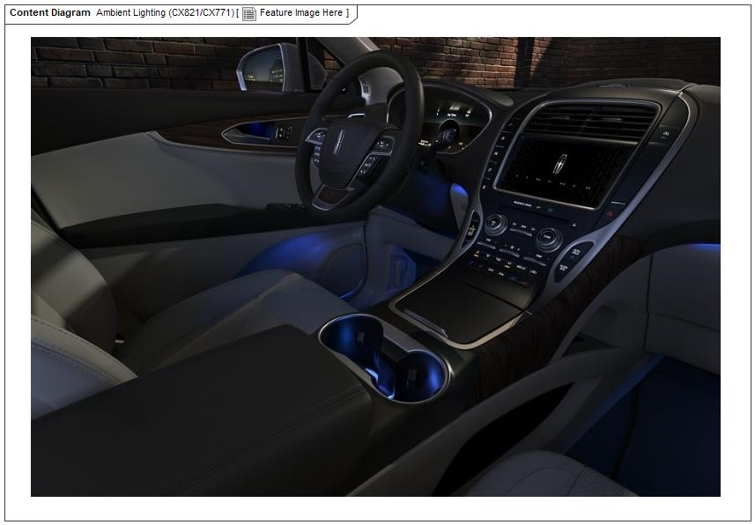

Figure 2: Feature Image Here

## Feature Variants

| **Variant Name** | **Variant Description** | **Remarks** |
| --- | --- | --- |
| **China Market_CX771_High_Series** | Door tram have(1 node,11 LEDs) need CAN Have communication Linear Lighting on Console(15 LEDs) need LIN communication |  |
| **China Market_CX771_Low_Series** | Door tram have(1 node,1 LEDs) need LIN communication Have communication Linear Lighting on Console(15 LEDs) need LIN communication |  |
| **China Market_CX821_High_Series** | Linear Lighting on IP(50~70 LEDs) Linear Lighting on Console(15 LEDs)  exist need CAN FD |  |
| **China Market_CX821_Low_Series** | Linear Lighting on IP(50~70 LEDs) & Linear Lighting on Console(15 LEDs) don't exist. No CAN_FD communication |  |

Table 6: Feature Variants

### Regions & Markets

| **Market /**  **Region**  Variant Name | **North America** | **South America** | **Europe** | **Middle East/Africa** | **Asia / Pacific** | **China** |
| --- | --- | --- | --- | --- | --- | --- |
| **China Market_CX771_High_Series** | No | No | No | No | No | Mandatory |
| **China Market_CX771_Low_Series** | No | No | No | No | No | Mandatory |
| **China Market_CX821_High_Series** | No | No | No | No | No | Mandatory |
| **China Market_CX821_Low_Series** | No | No | No | No | No | Mandatory |

Table 7: Regions & Markets

## Input Requirements/Documents

| **Reference**  (Reference as listed in ch. “References”) | **Section/Requirement** | **Description** | **Derived Requirement**  (optional – reference to requirement in ch. “Feature Requirements”) |
| --- | --- | --- | --- |
| **Attribute Requirements** | | | |
|  | EMC |  |  |
| **Ford Engineering Standards** | | | |
|  | <Example: some SDS (requirement)> |  |  |
| **Legal Regulations** | | | |
|  | Compliance with FMVSS101 | The Feature shall comply with FMVSS101. |  |
| **Industry Standards** | | | |
|  | ISO 26262 | The system should be developed according to Ford's implementation of Functional Safety. |  |
| **Other Sources** | | | |

Table 8: Input Requirements/Documents

## Lessons Learned

No lessons learned specified.

## Assumptions

No Assumptions specified.

# Feature Context

## Feature Context Diagram

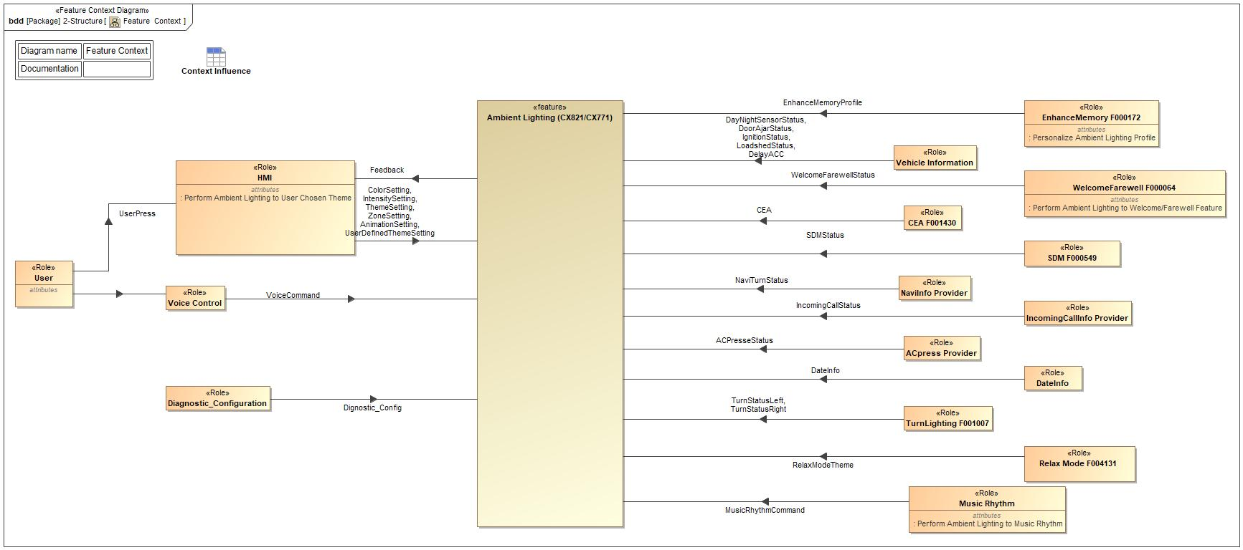

Figure 4: Feature Context

## List of Influences

| **ID** | **External Entity** | **Influence Description** |
| --- | --- | --- |
| ACPresseStatus | ACpress Provider To Ambient Lighting (CX821/CX771) | The status of AC button pressing. |
| HMI To Ambient Lighting (CX821/CX771) | The status of AC button pressing. |
| AnimationSetting | HMI To Ambient Lighting (CX821/CX771) | User chosen animation of certain zone. |
| CEA | CEA F001430 To Ambient Lighting (CX821/CX771) | CEA function On Off status. |
| ColorSetting | HMI To Ambient Lighting (CX821/CX771) | User chosen color of certain zone. |
| DateInfo | DateInfo To Ambient Lighting (CX821/CX771) | Date information provider. |
| Vehicle Information To Ambient Lighting (CX821/CX771) | Date information provider. |
| DayNightSensorStatus | Vehicle Information To Ambient Lighting (CX821/CX771) | Dimming level information from rain light sensor. |
| DelayACC | Vehicle Information To Ambient Lighting (CX821/CX771) | The status of AC button pressing. |
| Dignostic_Config | Diagnostic_Configuration To Ambient Lighting (CX821/CX771) | The status of AC button pressing. |
| DoorAjarStatus | Vehicle Information To Ambient Lighting (CX821/CX771) | Door ajar status of 4 doors. |
| EnhanceMemoryProfile | EnhanceMemory F000172 To Ambient Lighting (CX821/CX771) | The status of AC button pressing. |
| Feedback | Ambient Lighting (CX821/CX771) To HMI | Feedback to HMI |
| IgnitionStatus | Vehicle Information To Ambient Lighting (CX821/CX771) | Vehicle ignition status. |
| IncomingCallStatus | IncomingCallInfo Provider To Ambient Lighting (CX821/CX771) | Incoming phone call status. |
| Vehicle Information To Ambient Lighting (CX821/CX771) | Incoming phone call status. |
| IntensitySetting | HMI To Ambient Lighting (CX821/CX771) | User Command. |
| LoadshedStatus | Vehicle Information To Ambient Lighting (CX821/CX771) | Battery loadshed information. |
| MusicRhythmCommand | Music Rhythm To Ambient Lighting (CX821/CX771) | Music Rhythm command. |
| NaviTurnStatus | NaviInfo Provider To Ambient Lighting (CX821/CX771) | Turn request from navigation function. |
| Vehicle Information To Ambient Lighting (CX821/CX771) | Turn request from navigation function. |
| RelaxModeTheme | Relax Mode F004131 To Ambient Lighting (CX821/CX771) | CEA function On Off status. |
| SDMStatus | SDM F000549 To Ambient Lighting (CX821/CX771) | Vehicle SDM status. |
| ThemeSetting | HMI To Ambient Lighting (CX821/CX771) | User chosen theme. |
| TurnStatusLeft | TurnLighting F001007 To Ambient Lighting (CX821/CX771) | Vehicel Turn light status. |
| Vehicle Information To Ambient Lighting (CX821/CX771) | Vehicel Turn light status. |
| TurnStatusRight | TurnLighting F001007 To Ambient Lighting (CX821/CX771) | Vehicel Turn light status. |
| UserDefinedThemeSetting | HMI To Ambient Lighting (CX821/CX771) | User set zone save to user defined theme. |
| UserPress | User To HMI | User HMI interface. |
| VoiceCommand | Voice Control To Ambient Lighting (CX821/CX771) | Voice command. |
| WelcomeFarewellStatus | WelcomeFarewell F000064 To Ambient Lighting (CX821/CX771) | Vehicle welcome/farewell status. |
| ZoneSetting | HMI To Ambient Lighting (CX821/CX771) | User chosen animation/color/intensity of certain zone. |

Table 9: List of Influences

# Feature Modeling

## Operation Modes and States

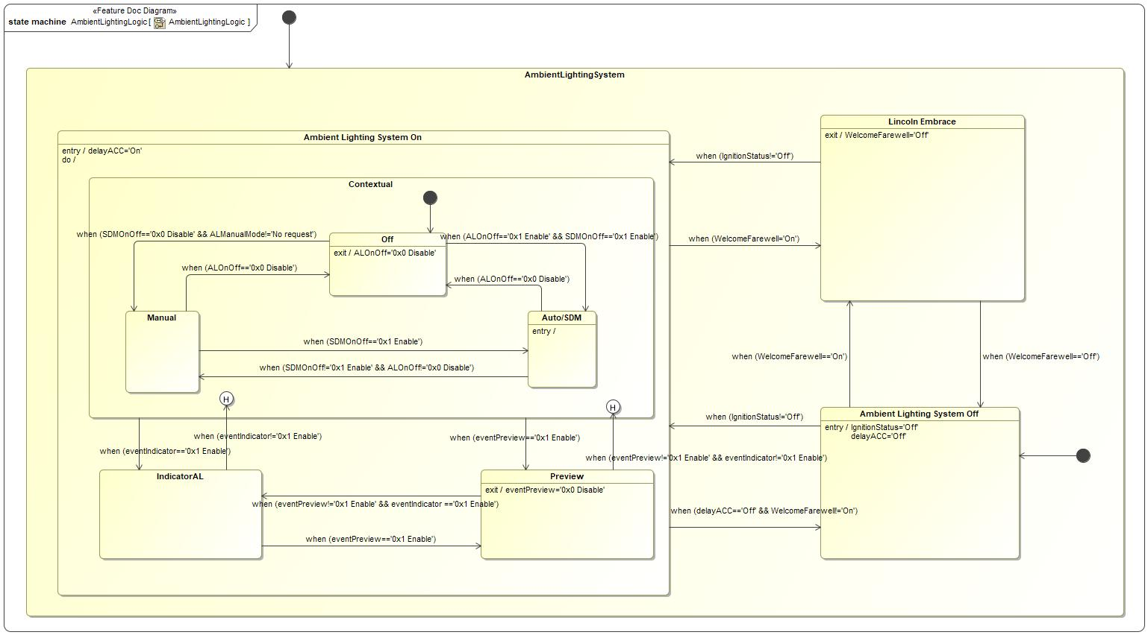

Figure 5: AmbientLightingLogic

| **State** | **Description** | **Requirements Reference** (optional) |
| --- | --- | --- |
| Ambient Lighting System Off | this status is when ambient lighting is off. |  |
| Ambient Lighting System On | this status is when ambient lighting is on. |  |
| AmbientLightingSystem | this is the whole ambient lighting system |  |
| Auto/SDM | this status is when ambient lighting in auto control, ambient lighting shall perform to SDM. |  |
| Contextual | this status is when ambient lighting shall output with whole vehicle lightings. |  |
| IndicatorAL | this status is when ambient lighting shall output with partial vehicle lightings. |  |
| Lincoln Embrace | this status is when ambient lighting system is in welcome/farewell mode. |  |
| Manual | this status is when ambient lighting is in manual control, ambient lighting shall perform to music rhythem/custom setting/prestore theme. |  |
| Off | this status is when ambient lighting is turns off by a user. |  |
| Preview | this status is when ambient lighting is play an animation in one cycle to indicator how a function performs. |  |

Table 10: Operation Modes and States on AmbientLightingLogic

| **Transition ID** | **Source** | **Destination** | **Description** | **Requirements Reference**  (optional) |
| --- | --- | --- | --- | --- |
| T1 | Preview | a | ChangeEvent when (eventPreview!='0x1 Enable' && eventIndicator!='0x1 Enable') |  |
| T2 | IndicatorAL | Preview | ChangeEvent when (eventPreview=='0x1 Enable') |  |
| T3 | Auto/SDM | Off | ChangeEvent when (ALOnOff=='0x0 Disable') |  |
| T4 |  |  |  |  |
| T5 | Contextual | Preview | ChangeEvent when (eventPreview=='0x1 Enable') |  |
| T6 | Preview | IndicatorAL | ChangeEvent when (eventPreview!='0x1 Enable' && eventIndicator =='0x1 Enable') |  |
| T7 | Lincoln Embrace | Ambient Lighting System Off | ChangeEvent when (WelcomeFarewell=='Off') |  |
| T8 | Manual | Auto/SDM | ChangeEvent when (SDMOnOff=='0x1 Enable') |  |
| T9 | Ambient Lighting System Off | Ambient Lighting System On | ChangeEvent when (IgnitionStatus!='Off') |  |
| T10 | Off | Manual | ChangeEvent when (SDMOnOff=='0x0 Disable' && ALManualMode!='No request') |  |
| T11 | Ambient Lighting System On | Lincoln Embrace | ChangeEvent when (WelcomeFarewell='On') |  |
| T12 | Ambient Lighting System Off | Lincoln Embrace | Documentation: 1-System Design  ChangeEvent when (WelcomeFarewell=='On') |  |
| T13 | Auto/SDM | Manual | ChangeEvent when (SDMOnOff!='0x1 Enable' && ALOnOff!='0x0 Disable') |  |
| T14 |  |  |  |  |
| T15 | Contextual | IndicatorAL | ChangeEvent when (eventIndicator=='0x1 Enable') |  |
| T16 | IndicatorAL | a | ChangeEvent when (eventIndicator!='0x1 Enable') |  |
| T17 | Lincoln Embrace | Ambient Lighting System On | Guard: =  ChangeEvent when (IgnitionStatus!='Off') |  |
| T18 | Off | Auto/SDM | ChangeEvent when (ALOnOff=='0x1 Enable' && SDMOnOff=='0x1 Enable') |  |
| T19 | Manual | Off | ChangeEvent when (ALOnOff=='0x0 Disable') |  |
| T20 |  |  |  |  |
| T21 | Ambient Lighting System On | Ambient Lighting System Off | Name: when (delayACC==off && IgnitionStatus=='Off'))  ChangeEvent when (delayACC=='Off' && WelcomeFarewell!='On') |  |

Table 11: Transitions between Operation Modes and States on AmbientLightingLogic

## Use Cases

### Use Case Diagram

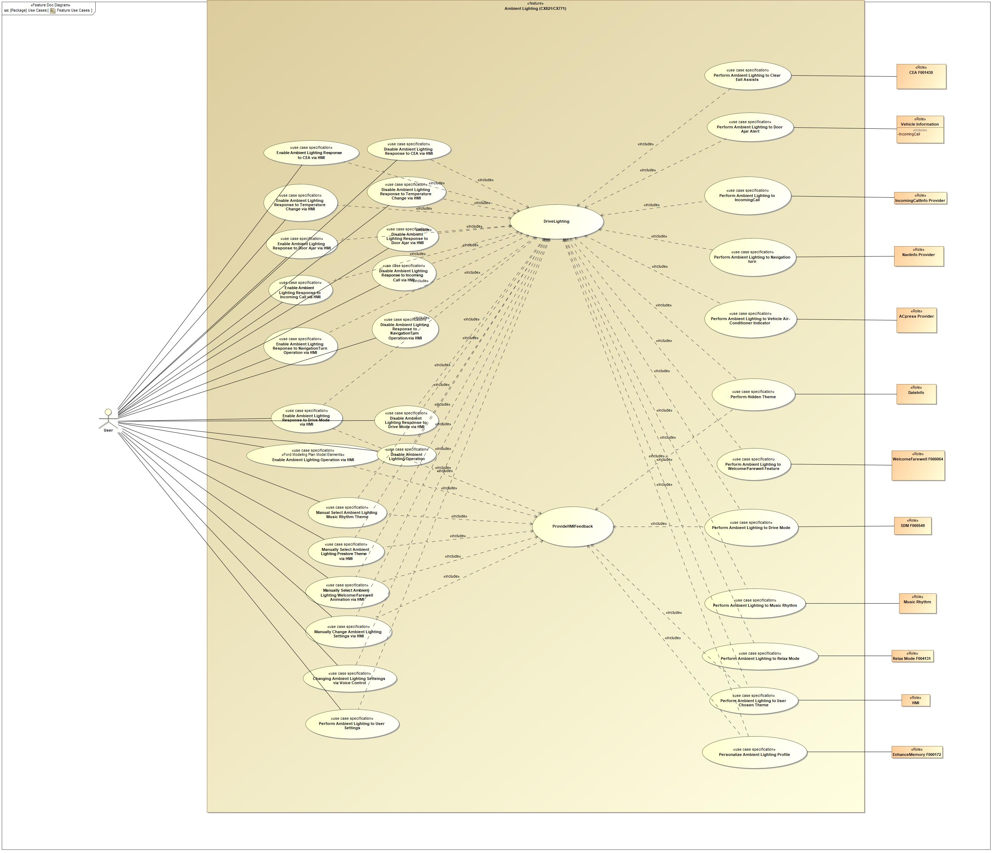

Figure 6: Feature Use Cases

### Actors

| **Actor** | **Description** |
| --- | --- |
| ACpress Provider | This is navigation turn status provider. |
| CEA F001430 | This is CEA feature. |
| DateInfo | This is date information provider. |
| EnhanceMemory F000172 | This is Enhance Memory Feature. |
| HMI | Role description on Documentation field. |
| IncomingCallInfo Provider | This is incoming call status provider. |
| Music Rhythm | This is Music Rhythm Commander. |
| NaviInfo Provider | This is navigation turn status provider. |
| Relax Mode F004131 | This is Relax Mode Feature. |
| SDM F000549 | This is Selectable Drive Mode feature. |
| User | This is the user. |
| Vehicle Information | This is vehicle information provider to provide door ajar status. |
| WelcomeFarewell F000064 | This is Welcome/Farewell Feature. |

Table 12: List of Actors

### Use Case Descriptions

UC_AMBL_00001 Enable Ambient Lighting Operation via HMI

|  |  |  |
| --- | --- | --- |
| **Actors** | Primary | User |
| Secondary |  |
| **Subject** |  | Ambient Lighting (CX821/CX771) |
| **Description** |  | To describe the scenario of manually select Enable /Disable ambient lighting |
| **Preconditions** | PreC1 | Ambient Lighting Operation is Off |
| PreC2 | Vehicle ignition is in RUN/START or delay acc is ON |
| **Main Flow** | M1 | User selectes ambient lighting on via HMI |
| **Alternative Flow Steps** | A1 | Ambient Lighting performs last saved setting |
| **Postconditions** | PostC1 | HMI Ambient Lighting Button change to On |
| PostC2 | HMI Ambient Lighting Opreation Mode activated |
| PostC3 | The Ambient Lighting opration turns On |

UC_AMBL_00002 Enable Ambient Lighting Response to Temperature Change via HMI

|  |  |  |
| --- | --- | --- |
| **Actors** | Primary | User |
| Secondary |  |
| **Subject** |  | Ambient Lighting (CX821/CX771) |
| **Description** |  | To describe the scenario of manually select Enable ambient lighting link to Air conditioning temperature change |
| **Preconditions** | PreC1 | Ambient Lighting to Temperature Change Function is Off |
| PreC2 | Vehicle ignition is in RUN/START or delay acc is ON |
| **Main Flow** | M1 | User selectes ambient lighting air condition temperature change function on via HMI |
| **Alternative Flow Steps** | A1 | If any request comes interrupt preview action, preview action ends |
| **Postconditions** | PostC1 | Ambient lighting performace Air Conditioning Temperature Change Operation turns On for preview |
| PostC2 | The HMI screen displays updated settings |

UC_AMBL_00003 Perform Ambient Lighting to User Settings

|  |  |  |
| --- | --- | --- |
| **Actors** | Primary | User |
| Secondary |  |
| **Subject** |  | Ambient Lighting (CX821/CX771) |
| **Description** |  | To describe a scenario of the feature responding to user setting. |
| **Preconditions** | PreC1 | Custom Setting is activated |
| PreC2 | Vehicle ignition is in RUN/START or delay acc is ON |
| **Main Flow** | M1 | User changes ambient lighting color/animation/intensity of zones |
| **Postconditions** | PostC1 | The Ambient Lighting performs to user setting |

UC_AMBL_00004 Enable Ambient Lighting Response to Drive Mode via HMI

|  |  |  |
| --- | --- | --- |
| **Actors** | Primary | User |
| Secondary |  |
| **Subject** |  | Ambient Lighting (CX821/CX771) |
| **Description** |  | To describe the scenario of manually select Enable ambient lighting link to drive mode |
| **Preconditions** | PreC1 | Ambient Ligthing to SDM is Off |
| PreC2 | Vehicle ignition is in RUN/START or delay acc is ON |
| **Main Flow** | M1 | User selectes ambient linghting to drive mode function On via HMI |
| **Alternative Flow Steps** | A1 | If Ambient Lighting Operation is Off previous to SDM turns On, Ambient Lighting Operation turns On |
| **Postconditions** | PostC1 | Ambient lighting performance link to vehicle drive mode  operation turns On |
| PostC2 | HMI Ambient Lighting to SDM Button change to On |

UC_AMBL_00005 Enable Ambient Lighting Response to Incoming Call via HMI

|  |  |  |
| --- | --- | --- |
| **Actors** | Primary | User |
| Secondary |  |
| **Subject** |  | Ambient Lighting (CX821/CX771) |
| **Description** |  | To describe the scenario of manually select Enable ambient lighting link to Incoming call |
| **Preconditions** | PreC1 | Ambient Lighting to Incoming Call is Off |
| PreC2 | Vehicle ignition is in RUN/START or delay acc is ON |
| **Main Flow** | M1 | User selectes ambient linghting Incoming call function On via HMI |
| **Alternative Flow Steps** | A1 | If any request comes interrupt preview action, preview action ends |
| **Postconditions** | PostC1 | Ambient lighting performance link to incoming call operation turns On |
| PostC2 | HMI Ambient Lighting to Incoming Call changes to On |

UC_AMBL_00006 Perform Hidden Theme

|  |  |  |
| --- | --- | --- |
| **Actors** | Primary | Ambient Lighting (CX821/CX771) |
| Secondary | User |
| **Subject** |  | Ambient Lighting (CX821/CX771) |
| **Description** |  | To describe the scenario of a hidden theme triggered on a specific day (New year, Christmas, Chinese new year, etc.). This theme will be available during this holiday. Hidden theme can be updated by ALCM/SYNC+ MMOTA. |
| **Preconditions** | PreC1 | Ambient Lighting Operation is Enabled |
| PreC2 | Vehicle ignition is in RUN/START or delay acc is ON |
| **Triggers** | T1 | At specific day |
| **Main Flow** | M1 | HMI pops up a reminder to user: a hidden theme can be selected |
| M2 | HMI enable hidden theme choose button |
| M3 | User selects this hidden theme |
| M4 | Ambient lighting performs to this hidden theme |
| **Postconditions** | PostC1 | If this hidden theme is on when disappear timing comes, Ambient lighting operation mode goes to defalut mode ( custom setting 1) |
| PostC2 | This new hidden theme will be hide again after x(configurable) days |

UC_AMBL_00007 Enable Ambient Lighting Response to NavigationTurn Operation via HMI

|  |  |  |
| --- | --- | --- |
| **Actors** | Primary | User |
| Secondary |  |
| **Subject** |  | Ambient Lighting (CX821/CX771) |
| **Description** |  | To describe the scenario of manually select Enable ambient lighting link to NavigationTurn |
| **Preconditions** | PreC1 | Ambient Lighting to Navigation Turn function is Off |
| PreC2 | Vehicle ignition is in RUN/START or delay acc is ON |
| **Main Flow** | M1 | User selectes ambient linghting navigation turn function On via HMI |
| **Alternative Flow Steps** | A1 | If any request comes interrupt preview action, preview action ends |
| **Postconditions** | PostC1 | Ambient lighting performance link to navigation turn  operation turns On for preview |
| PostC2 | HMI Ambient Lighting to Navigation Turn Button changes to On |

UC_AMBL_00008 Perform Ambient Lighting to User Chosen Theme

|  |  |  |
| --- | --- | --- |
| **Actors** | Primary | User |
| Secondary |  |
| **Subject** |  | Ambient Lighting (CX821/CX771) |
| **Description** |  | To describe the scenario of changing ambient lighting color/intensity to theme number when user changes the theme by feature HMI. |
| **Preconditions** | PreC1 | Ambient Lighting Operation Mode is in Theme mode |
| PreC2 | Ambient Lighting Operation is Enable |
| PreC3 | Vehicle ignition is in RUN/START or delay acc is ON |
| **Main Flow** | M1 | Ambient Lighting performs to selected theme |

UC_AMBL_00009 Perform Ambient Lighting to Welcome/Farewell Feature

|  |  |  |
| --- | --- | --- |
| **Actors** | Primary | User |
| Secondary | WelcomeFarewell F000064 |
| **Subject** |  | Ambient Lighting (CX821/CX771) |
| **Description** |  | To describe a scenario of the feature responding to a Welcome Farewell Trigger. For a full list of triggers and behaviors refer to the Welcome Farewell / Lincoln Embrace Strategy RQT-002004-704098. |
| **Preconditions** | PreC1 | Vehicle Ignition is OFF |
| **Triggers** | T1 | Welcome/farewell event |
| **Main Flow** | M1 | The User interacts with the Welcome Farewell feature |
| M2 | Welcome Farewell instructs ambient lighting to perform with a specific animation |

UC_AMBL_00010 Manually Change Ambient Lighting Settings via HMI

|  |  |  |
| --- | --- | --- |
| **Actors** | Primary | User |
| Secondary |  |
| **Subject** |  | Ambient Lighting (CX821/CX771) |
| **Description** |  | To describe the scenario of changing ambient lighting color, intensity and animation effects by zones. |
| **Preconditions** | PreC1 | Ambient Lighting Operation is Enable |
| PreC2 | Ambient Ligthing Operation Mode is in custom mode |
| PreC3 | Vehicle ignition is in RUN/START or delay acc is ON |
| **Main Flow** | M1 | User goes to zone setting page through feature HMI |
| M2 | User changes Ambient Lighting color/brightness/animation (allows separate zone setting) through feature of HMI |
| **Postconditions** | PostC1 | The Ambient Lighting is ON with this adjusted color/intensity/animation |
| PostC2 | The HMI screen displays updated settings |

UC_AMBL_00011 Perform Ambient Lighting to Relax Mode

|  |  |  |
| --- | --- | --- |
| **Actors** | Primary | Relax Mode F004131 |
| Secondary |  |
| **Subject** |  | Ambient Lighting (CX821/CX771) |
| **Description** |  | To describe a scenario of the feature responding to Relax Mode Feature. |
| **Preconditions** | PreC1 | Relax Mode is On |
| PreC2 | Vehicle ignition is in RUN/START |
| **Main Flow** | M1 | User selectes Relax Mode Theme Type via HMI |
| **Postconditions** | PostC1 | Ambient Lighting performance link to Relax Mode Theme Type |

UC_AMBL_00012 Manually Select Ambient Lighting Prestore Theme via HMI

|  |  |  |
| --- | --- | --- |
| **Actors** | Primary | User |
| Secondary |  |
| **Subject** |  | Ambient Lighting (CX821/CX771) |
| **Description** |  | To describe the scenario of changing ambient lighting preset theme through feature HMI (three preset animations) |
| **Preconditions** | PreC1 | Ambient Lighting Operation is Enabled |
| PreC2 | Vehicle ignition is in RUN/START or delay acc is ON |
| **Main Flow** | M1 | User goes to theme selected page via HMI |
| M2 | User selects one of prestore themes type (three options) |
| **Postconditions** | PostC1 | HMI: Selected Theme is highlighted |
| PostC2 | The Ambient Lighting performs to selected theme |

UC_AMBL_00013 Manually Select Ambient Lighting Welcome/Farewell Animation via HMI

|  |  |  |
| --- | --- | --- |
| **Actors** | Primary | User |
| Secondary |  |
| **Subject** |  | Ambient Lighting (CX821/CX771) |
| **Description** |  | To describe the scenario of changing ambient lighting preset welcome/farewell animation through feature HMI (three preset animations) |
| **Preconditions** | PreC1 | Ambient lighting Operation is Enable |
| PreC2 | Vehicle ignition is in RUN/START or delay acc is ON |
| **Main Flow** | M1 | User goes to welcome/farewell animation select page through feature HMI |
| M2 | User selects prestore wellcome/farewell animation |
| **Alternative Flow Steps** | A1 | If any request comes interrupt preview action, preview action ends |
| **Postconditions** | PostC1 | The Ambient Lighting is On with selected wellcome/farewell animation for preview |
| PostC2 | The HMI screen displays updated settings |

UC_AMBL_00014 Perform Ambient Lighting to Drive Mode

|  |  |  |
| --- | --- | --- |
| **Actors** | Primary | User |
| Secondary |  |
| **Subject** |  | Ambient Lighting (CX821/CX771) |
| **Description** |  | To describe the scenario of changing ambient lighting theme called by feature SDM |
| **Preconditions** | PreC1 | Ambient Lighting Operation is Enable |
| PreC2 | Ambient Lighting Operation is in SDM mode |
| PreC3 | Vehicle ignition is in RUN/START or delay acc is ON |
| **Triggers** | T1 | Selectable drive mode event |
| **Main Flow** | M1 | Ambient Lighting performs to selected drive mode |
| **Alternative Flow Steps** | A1 | User changes vehcle drive mode |
| A2 | Ambient Lighting performs to selected drive mode |

UC_AMBL_00015 Perform Ambient Lighting to Clear Exit Assists

|  |  |  |
| --- | --- | --- |
| **Actors** | Primary | CEA F001430 |
| Secondary |  |
| **Subject** |  | Ambient Lighting (CX821/CX771) |
| **Description** |  | To describe the scenario of changing partial ambient lighting animation called by feature CEA |
| **Preconditions** | PreC1 | All door closed |
| PreC2 | Ambient Lighting Clear Exit Assists function is enabled |
| PreC3 | Ambient Lighting Operation is Enable |
| PreC4 | Clear Exit Assist function is Enable |
| PreC5 | Vehicle ignition is in RUN/START or delay acc is ON |
| **Triggers** | T1 | Clear exsit assists event |
| **Main Flow** | M1 | CEA relative door opens |
| M2 | Ambient Lighting to CEA performs on relative door |
| **Postconditions** | PostC1 | Ambient Lighting Performance changes back to previous ambient lighting setting |

UC_AMBL_00016 Perform Ambient Lighting to Door Ajar Alert

|  |  |  |
| --- | --- | --- |
| **Actors** | Primary | Vehicle Information |
| Secondary |  |
| **Subject** |  | Ambient Lighting (CX821/CX771) |
| **Description** |  | To describe the scenario of changing ambient lighting color in door handle when any door is ajar and vehicle speed is over 5kph |
| **Preconditions** | PreC1 | All door closed |
| PreC2 | Ambient Lighting Operation is Enable |
| PreC3 | Ambient Lighting to Door Ajar function is on |
| PreC4 | CEA indicator is not triggers on of relative door |
| PreC5 | User drive the vehicle and vehicle speed is higher than 5km/h(configurable) |
| PreC6 | Vehicle ignition is in RUN/START or delay acc is ON |
| **Triggers** | T1 | Door ajar event |
| **Main Flow** | M1 | Open any door or doors |
| M2 | Ambient Lighting performs to relative door |
| M3 | Close the door or doors |
| M4 | Ambient Lighting stops performing to door ajar function |
| **Alternative Flow Steps** | A1 | CEA indicator request comes |
| A2 | Door Ajar indictor interrupts and Ambient Lighting performs to CEA indicator request |
| A3 | CEA indicator ends, Ambient Lighting performs to door ajar indicator again |
| **Postconditions** | PostC1 | Ambient Lighting Performance changes back to previous ambient lighting setting |

UC_AMBL_00017 Perform Ambient Lighting to IncomingCall

|  |  |  |
| --- | --- | --- |
| **Actors** | Primary | IncomingCallInfo Provider |
| Secondary |  |
| **Subject** |  | Ambient Lighting (CX821/CX771) |
| **Description** |  | To describe the scenario of changing ambient lighting color/intensity (partial ambient lightings at left side of IP) to in coming call when a phone call is in calling status |
| **Preconditions** | PreC1 | A phone call is coming |
| PreC2 | Ambient Lighting Operation is Enable |
| PreC3 | Ambient lighting incoming call function is On |
| PreC4 | User contect mobile phone to IVI by bluetooth/usb |
| PreC5 | Vehicle ignition is in RUN/START or delay acc is ON |
| **Triggers** | T1 | Incoming call event |
| **Main Flow** | M1 | Ambient Lighting performs to incoming call |
| M2 | User answer or hang up the phone |
| M3 | Ambient lighting stops performing to incoming call animation |
| **Alternative Flow Description** |  | User anser a phone call |
| **Alternative Flow Description** |  | A second call is coming |
| **Alternative Flow Description** |  | Ambient Lighting performs to second incoming call event |
| **Postconditions** | PostC1 | Ambient Lighting Performance changes back to previous ambient lighting setting |

UC_AMBL_00018 Perform Ambient Lighting to Navigation turn

|  |  |  |
| --- | --- | --- |
| **Actors** | Primary | NaviInfo Provider |
| Secondary |  |
| **Subject** |  | Ambient Lighting (CX821/CX771) |
| **Description** |  | To describe the scenario of changing ambient lighting color/intensity (partial ambient lightings at IP, to be defined) to naviTurn animation when Navigation tells user to turn left or right |
| **Preconditions** | PreC1 | Ambient Lighting Navigation function is On |
| PreC2 | Ambient Lighting Operation is Enable |
| PreC3 | Navigation operates and sends out turn left/turn right command |
| PreC4 | Vehicle ignition is in RUN/START or delay acc is ON |
| **Triggers** | T1 | The navigation turn event |
| **Main Flow** | M1 | Ambient lighting performs to NaviTurn animation |
| M2 | User flip the steering lever to right or left |
| M3 | Ambient lighting stops performing NaviTurn animation |
| **Postconditions** | PostC1 | Ambient Lighting Performance changes back to previous ambient lighting setting |

UC_AMBL_00019 Perform Ambient Lighting to Vehicle Air-Conditioner Indicator

|  |  |  |
| --- | --- | --- |
| **Actors** | Primary | User |
| Secondary |  |
| **Subject** |  | Ambient Lighting (CX821/CX771) |
| **Subject** |  | Animation For CX771 Air Temperature Change |
| **Description** |  | To describe the scenario of changing ambient lighting animation (partial ambient lightings at left side of IP) to temperature change when user changes the temperature by pressing hard button or soft button |
| **Preconditions** | PreC1 | Ambient Lighting Operation is Enable |
| PreC2 | Ambient Lighting temperature change function is On |
| PreC3 | Vehicle ignition is in RUN/START or delay acc is ON |
| **Main Flow** | M1 | User changes the of air temperature setting by pressing drive side/passage side button |
| M2 | Temperature change message (driver side/passenger side)sends out |
| M3 | Ambient Ligting performs animation of driver/passenger side (temperature increase: do animation in orange color/temperature decrease: do animation in blue color) |
| M4 | User stops changing temperature |
| M5 | Ambient Lighting keeps on addinitional 300 ms then stops performing temperature adjust pattern |
| **Postconditions** | PostC1 | Ambient Lighting Performance changes back to previous ambient lighting setting |

UC_AMBL_00020 Changing Ambient Lighting Setteings via Voice Control

|  |  |  |
| --- | --- | --- |
| **Actors** | Primary | User |
| Secondary |  |
| **Subject** |  | Ambient Lighting (CX821/CX771) |
| **Subject** |  | VoiceControl |
| **Description** |  | To describe the scenario of a user changing Ambient Lighting setting through voice control |
| **Preconditions** | PreC1 | Vehicle Voice Control (VPA) is active |
| PreC2 | Vehicle ignition is in RUN/START or delay acc is ON |
| **Main Flow** | M1 | User speak to vehicle, asking for Ambient Lighting setting change |
| **Postconditions** | PostC1 | The Ambient Lighting performing change according to user inputs |
| PostC2 | The HMI screen displays the updated setting |

UC_AMBL_00021 Personalize Ambient Lighting Profile

|  |  |  |
| --- | --- | --- |
| **Actors** | Primary | User |
| Secondary |  |
| **Subject** |  | Ambient Lighting (CX821/CX771) |
| **Description** |  | Describes the scenario of changing ambient lighting settings through interaction with the Enhanced Memory Feature.  Refer to Enhanced Memory feature document (F000172) for more details on enhance memory use case. |
| **Preconditions** | PreC1 | Vehicle equipped with Enhanced Memory |
| PreC2 | Vehicle ignition is in RUN/START or delay acc is ON |
| **Main Flow** | M1 | User changes profile X to profile Y |
| M2 | Ambient lighting performs settings in profile Y |
| **Alternative Flow Steps** | A1 | User reset profile |
| A2 | Profile X content goes to factory setting |
| A3 | User create profile |
| A4 | Profile X content created |
| **Postconditions** | PostC1 | The HMI screen displays the updated setting |

UC_AMBL_00022 Manual Select Ambient Lighting Music Rhythm Theme

|  |  |  |
| --- | --- | --- |
| **Actors** | Primary | User |
| Secondary |  |
| **Subject** |  | Ambient Lighting (CX821/CX771) |
| **Description** |  | To describe a scenario of choose 2 type of music rhythm |
| **Preconditions** | PreC1 | Ambient Lighting is Enable |
| PreC2 | Vehicle ignition is in RUN/START or delay acc is ON |
| **Main Flow** | M1 | User selects music rhythm type |
| M2 | User turns on music |
| **Postconditions** | PostC1 | Ambient Lighting performs to user inputs & music input |
| PostC2 | The HMI screen displays the updated setting |

UC_AMBL_00023 Disable Ambient Lighting Operation

|  |  |  |
| --- | --- | --- |
| **Actors** | Primary | User |
| Secondary |  |
| **Subject** |  | Ambient Lighting (CX821/CX771) |
| **Description** |  | To describe the scenario of manually select Disable ambient lighting |
| **Preconditions** | PreC1 | Ambient Lighting is in On operation |
| PreC2 | Vehicle ignition is in RUN/START or delay acc is ON |
| **Main Flow** | M1 | User selectes Ambient Lighting Operation Off via HMI |
| **Postconditions** | PostC1 | HMI: Ambient Lighting SDM OnOff Button turns Off |
| PostC2 | HMI: Ambinet Lighting Operation Button turns Off |
| PostC3 | The Ambient Lighting Opration turns Off |

UC_AMBL_00024 Perform Ambient Lighting to Music Rhythm

|  |  |  |
| --- | --- | --- |
| **Actors** | Primary | Music Rhythm |
| Secondary |  |
| **Subject** |  | Ambient Lighting (CX821/CX771) |
| **Description** |  | To describe a scenario of the feature responding to Music Rhythm. |
| **Preconditions** | PreC1 | Ambient Lighting perform to Music Rhythm selected On via HMI |
| PreC2 | Vehicle ignition is in RUN/START or delay acc is ON |
| **Main Flow** | M1 | User turns on music |
| **Postconditions** | PostC1 | Ambient Lighting performs to Music Range and Frequency |

UC_AMBL_00025 Disable Ambient Lighting Response to Drive Mode via HMI

|  |  |  |
| --- | --- | --- |
| **Actors** | Primary | User |
| Secondary |  |
| **Subject** |  | Ambient Lighting (CX821/CX771) |
| **Description** |  | To describe the scenario of manually select Disable ambient lighting link to drive mode |
| **Preconditions** | PreC1 | Ambient Lighting Operation is On |
| PreC2 | Ambient Lighting SDM function is On |
| PreC3 | Vehicle ignition is in RUN/START or delay acc is ON |
| **Main Flow** | M1 | User selectes Ambient Lighting Drive Mode function Off via HMI |
| **Postconditions** | PostC1 | Ambient Lighting performs to Ambient Lighting Operation Mode |
| PostC2 | Ambient Lighting performs to drive mode operation turns Off |
| PostC3 | HMI: Ambient Lighing Operation Mode is selected |
| PostC4 | HMI: Ambient Lighting SDM Button turns Off |

UC_AMBL_00026 Disable Ambient Lighting Response to Incoming Call via HMI

|  |  |  |
| --- | --- | --- |
| **Actors** | Primary | User |
| Secondary |  |
| **Subject** |  | Ambient Lighting (CX821/CX771) |
| **Description** |  | To describe the scenario of manually select Disable ambient lighting link to Incomingcall |
| **Preconditions** | PreC1 | Ambient Lighting Incoming Call function is On |
| PreC2 | Ambient Lighting Operation is Enable |
| PreC3 | Vehicle ignition is in RUN/START or delay acc is ON |
| **Main Flow** | M1 | User selectes Ambient Lighting Incoming Call function Off via HMI |
| **Alternative Flow Description** |  | If any request comes interrupt preview action, preview action ends |
| **Postconditions** | PostC1 | Ambient Lighting performs to incoming call function turns Off |
| PostC2 | HMI: Ambient Lighting Incoming Call Button turns Off |

UC_AMBL_00027 Enable Ambient Lighting Response to CEA via HMI

|  |  |  |
| --- | --- | --- |
| **Actors** | Primary | User |
| Secondary |  |
| **Subject** |  | Ambient Lighting (CX821/CX771) |
| **Description** |  | To describe the scenario of manually select Enable ambient lighting link to CEA |
| **Preconditions** | PreC1 | Ambient Lighting CEA function is Off |
| PreC2 | Ambient Lighting Operation is Enable |
| PreC3 | Vehicle ignition is in RUN/START or delay acc is ON |
| **Main Flow** | M1 | User selectes Ambient Lighting with CEA indicator function On via HMI |
| **Postconditions** | PostC1 | Ambient Lighting performs to CEA operation turns On for preview |
| PostC2 | HMI: Ambient Lighting CEA Button turns On |

UC_AMBL_00028 Disable Ambient Lighting Response to NavigationTurn Operation via HMI

|  |  |  |
| --- | --- | --- |
| **Actors** | Primary | User |
| Secondary |  |
| **Subject** |  | Ambient Lighting (CX821/CX771) |
| **Description** |  | To describe the scenario of manually select Disable ambient lighting link to NavigationTurn |
| **Preconditions** | PreC1 | Ambient Lighting Navigation Turn function is On |
| PreC2 | Ambient Lighting Operation is Enable |
| PreC3 | Vehicle ignition is in RUN/START or delay acc is ON |
| **Main Flow** | M1 | User selectes Ambient Lighting navigation turn function Off via HMI |
| **Postconditions** | PostC1 | Ambient Lighting performs to navigation turn operation turns Off |
| PostC2 | HMI: Ambient Lighting Navigation Turn Button turns Off |

UC_AMBL_00029 Disable Ambient Lighting Response to Temperature Change via HMI

|  |  |  |
| --- | --- | --- |
| **Actors** | Primary | User |
| Secondary |  |
| **Subject** |  | Ambient Lighting (CX821/CX771) |
| **Description** |  | To describe the scenario of manually select Disable ambient lighting link to Air conditioning temperature change |
| **Preconditions** | PreC1 | Ambient Lighting Operation is Enable |
| PreC2 | Ambient Lighting Temprature Change function is On |
| PreC3 | Vehicle ignition is in RUN/START or delay acc is ON |
| **Main Flow** | M1 | User selectes Ambient Lighting air condition temperature change function Off via HMI |
| **Postconditions** | PostC1 | Ambient Lighting performs to Air Conditioning Temperature Change Operation turns Off |
| PostC2 | HMI: Ambient Lighting Temerature Change Button turns Off |

UC_AMBL_00030 Disable Ambient Lighting Response to CEA via HMI

|  |  |  |
| --- | --- | --- |
| **Actors** | Primary | User |
| Secondary |  |
| **Subject** |  | Ambient Lighting (CX821/CX771) |
| **Description** |  | To describe the scenario of manually select Disable ambient lighting link to CEA |
| **Preconditions** | PreC1 | Ambient Lighting CEA function is On |
| PreC2 | Ambient Lighting Operation is Enable |
| PreC3 | Vehicle ignition is in RUN/START or delay acc is ON |
| **Main Flow** | M1 | User selectes ambient lighting CEA function Off via HMI |
| **Postconditions** | PostC1 | Ambient lighting performance link to CEA operation turns Off |
| PostC2 | HMI: Ambient Lighting CEA Button turns Off |

UC_AMBL_00031 Disable Ambient Lighting Response to Door Ajar via HMI

|  |  |  |
| --- | --- | --- |
| **Actors** | Primary | User |
| Secondary |  |
| **Subject** |  | Ambient Lighting (CX821/CX771) |
| **Description** |  | To describe the scenario of manually select Disable ambient lighting link to Door Ajar |
| **Preconditions** | PreC1 | Ambient Lighting Door Ajar function is On |
| PreC2 | Ambient Lighting Operation is Enable |
| PreC3 | Vehicle ignition is in RUN/START or delay acc is ON |
| **Main Flow** | M1 | User selectes ambient linghting Door Ajar Indicator function Off via HMI |
| **Postconditions** | PostC1 | Ambient Lighting performs to Door Ajar function turns Off |
| PostC2 | HMI:Ambient Lighting Door Ajar Button turns Off |

UC_AMBL_00032 Enable Ambient Lighting Response to Door Ajar via HMI

|  |  |  |
| --- | --- | --- |
| **Actors** | Primary | User |
| Secondary |  |
| **Subject** |  | Ambient Lighting (CX821/CX771) |
| **Description** |  | To describe the scenario of manually select Enable ambient lighting link to Door Ajar |
| **Preconditions** | PreC1 | Ambient Lighting Door Ajar function is Off |
| PreC2 | Ambient Lighting Operation is Enable |
| PreC3 | Vehicle ignition is in RUN/START or delay acc is ON |
| **Main Flow** | M1 | User selectes Ambient Lighhting Door Ajar Indicator function On via HMI |
| **Alternative Flow Description** |  | If any request comes interrupt preview action, preview action ends |
| **Postconditions** | PostC1 | Ambient Lighting performs to Door Ajar function turns On for preview |
| PostC2 | HMI: Ambient Lighting Door Ajar Button turns On |

## Driving and Operation Scenarios

## Decision Tables

# Feature Requirements

()

(true)

()

## Functional Requirements

R_F_AMBL_15 Ambient Lighting System Shall Perform Ambient Lighting In Response To HMI Settings

Ambient Lighting shall respond to HMI command once user make a change via HMI.

|  |  |  |  |  |  |  |  |
| --- | --- | --- | --- | --- | --- | --- | --- |
| Requirement ID: R_F_AMBL_15 | | | | | | | |
| **Rationale** |  | | | | | | |
| **Acceptance Criteria** |  | | | | | | |
| **Notes** | Functional Requirement | | | | | | |
| **Source** |  | | | | | **Owner** |  |
| **Source Req.** |  | | | | | **V&V Method** |  |
| **Type** |  | | | **Priority** | 1 - High | **Status** | Approved |
| [Req. Template](http://wiki.ford.com/display/RequirementsEngineering/Requirements+Attributes) Version | | 6.0 | End of Requirement | | | | |

R_F_AMBL_16 Perform Ambient Lighting In Response To Drive Mode

While ambient lighting operation is enable ambient lighting link to driver mode is enable, user changes drive mode, ambient lighting shall perform to user changed drive mode. Each drive mode have a specific effect.

|  |  |  |  |  |  |  |  |
| --- | --- | --- | --- | --- | --- | --- | --- |
| Requirement ID: R_F_AMBL_16 | | | | | | | |
| **Rationale** |  | | | | | | |
| **Acceptance Criteria** | Prestored theme effects linked to each drive mode. | | | | | | |
| **Notes** | Functional Requirement | | | | | | |
| **Source** |  | | | | | **Owner** |  |
| **Source Req.** |  | | | | | **V&V Method** |  |
| **Type** |  | | | **Priority** | 1 - High | **Status** | Approved |
| [Req. Template](http://wiki.ford.com/display/RequirementsEngineering/Requirements+Attributes) Version | | 6.0 | End of Requirement | | | | |

R_F_AMBL_17 Perform Ambient Lighting In Response To Voice Control Command

While in Ambient Lighting operation mode, Ambient Lighting shall change setting linked to voice control mode with the host vehicle.

|  |  |  |  |  |  |  |  |  |  |  |  |  |  |  |  |  |  |  |  |  |  |  |  |  |  |  |  |  |  |  |  |  |  |  |  |  |  |  |  |  |  |  |  |  |  |  |  |  |  |  |  |  |  |  |  |  |  |  |  |  |  |  |  |  |  |  |  |  |  |  |  |  |  |  |  |  |  |  |  |  |  |  |  |  |  |  |  |  |  |  |  |  |  |  |  |  |  |  |  |  |  |  |  |  |  |  |  |
| --- | --- | --- | --- | --- | --- | --- | --- | --- | --- | --- | --- | --- | --- | --- | --- | --- | --- | --- | --- | --- | --- | --- | --- | --- | --- | --- | --- | --- | --- | --- | --- | --- | --- | --- | --- | --- | --- | --- | --- | --- | --- | --- | --- | --- | --- | --- | --- | --- | --- | --- | --- | --- | --- | --- | --- | --- | --- | --- | --- | --- | --- | --- | --- | --- | --- | --- | --- | --- | --- | --- | --- | --- | --- | --- | --- | --- | --- | --- | --- | --- | --- | --- | --- | --- | --- | --- | --- | --- | --- | --- | --- | --- | --- | --- | --- | --- | --- | --- | --- | --- | --- | --- | --- | --- | --- | --- | --- |
| |  |  |  |  |  |  | | --- | --- | --- | --- | --- | --- | | **控制范围** | **指令基线** | **泛化指令** | **前置条件** | **前端反应** | **TTS播报** | | 打开 | 打开氛围灯 | 打开氛围灯  帮我打开氛围灯  我想开氛围灯  我想打开氛围灯  开启氛围灯  开一下氛围灯  氛围灯开  我要开氛围灯  给我打开氛围灯 | 无 | 氛围灯打开；默认上次的设置项打开 | 氛围灯开关已开启 | | 关闭 | 关闭氛围灯 | 关闭氛围灯  帮我关闭氛围灯  关掉氛围灯  我要关掉氛围灯  关一下氛围灯  氛围灯关上  氛围灯关闭 | 无 | 氛围灯关闭 | 氛围灯开关已关闭 | | 调节亮度 | 氛围灯亮度调高（默认+20%） | 调亮氛围灯亮度 | 氛围灯已经打开 | 氛围灯亮度调高（默认+20%） | 亮度已调高  如果调节范围超过最大值，tts反馈：氛围灯亮度已调节的最高 | | 氛围灯亮度调高到具体x% | 氛围灯亮度调高到x%（X：1-100的数字） | 氛围灯已经打开 | 氛围灯亮度调到X% | 氛围灯亮度已调到X%  如果调节范围超过最大值，tts反馈：氛围灯亮度已调节的最高 | | 氛围灯亮度调低（默认-20%） | 氛围灯亮度降低 | 氛围灯已经打开 | 氛围灯亮度调低（默认-20%） | 氛围灯亮度已调低  如果调节范围超过最小值，tts反馈：氛围灯亮度已调节的最低 | | 氛围灯亮度调低到具体x% | 氛围灯亮度调低到x%（X：1-100的数字） | 氛围灯已经打开 | 氛围灯亮度调到X% | 氛围灯亮度已调低调到X%  如果调节范围超过最小值，tts反馈：氛围灯亮度已调节的最低 | | 氛围灯亮度最亮 | 氛围灯亮度最亮 | 调节氛围灯亮度最亮/氛围灯亮度调到最亮 | 氛围灯已经打开 | 氛围灯亮度最亮 | 亮度已调节到最高 | | 氛围灯亮度最低 | 氛围灯亮度最低 | 调节氛围灯亮度最低/氛围灯亮度调到最低 | 氛围灯已经打开 | 氛围灯亮度最低 | 亮度已调节到最低 | | 音乐律动 | 打开音乐律动 | 把音乐律动打开 | 氛围灯已经打开 | 音乐律动打开 | 音乐律动已打开 | | 选择音乐律动主题？ | 换一个音乐律动主题 | 氛围灯已经打开/音乐律动模式已打开 |  |  | | 氛围灯来电提醒 | 打开氛围灯来电提醒 | 打开氛围灯来电提醒 | 氛围灯已经打开 | 打开氛围灯来电提醒同时氛围灯区域控制界面已打开 | 氛围灯来电提醒已打开 | | 关闭氛围灯来电提醒 | 关闭氛围灯来电提醒 | 氛围灯已经打开 | 关闭氛围灯来电提醒同时氛围灯区域控制界面已关闭 | 氛围灯来电提醒已关闭 | | 氛围灯导航提醒 | 打开氛围灯导航提醒 | 打开氛围灯导航提醒 | 氛围灯已经打开 | 打开氛围灯导航提醒同时氛围灯区域控制界面已打开 | 氛围灯导航提醒已打开 | | 关闭氛围灯导航提醒 | 关闭氛围灯导航提醒 | 氛围灯已经打开 | 关闭氛围灯导航提醒同时氛围灯区域控制界面已关闭 | 氛围灯导航提醒已关闭 | | 氛围灯门未关提醒 | 打开氛围灯门未关提醒 | 打开氛围灯门未关提醒 | 氛围灯已经打开 | 打开氛围灯门未关提醒同时氛围灯区域控制界面已打开 | 氛围灯门未关提醒已打开 | | 关闭氛围灯门未关提醒 | 关闭氛围灯门未关提醒 | 氛围灯已经打开 | 关闭氛围灯门未关提醒同时氛围灯区域控制界面已关闭 | 氛围灯门未关提醒提醒已关闭 | | 切换氛围灯主题 | 切换氛围灯主题到？ | 切换氛围灯主题到？ | 氛围灯已经打开 | 1氛围灯切换到主题模式 2氛围灯主题切换界面更新选择主题 | 氛围灯切换到主题模式 氛围灯主题切换界面已切换至？ | | 打开氛围灯自定义界面 | 打开氛围灯自定义界面 | 打开氛围灯自定义界面 | 氛围灯已经打开 | 氛围灯自定义界面打开 | 氛围灯自定义界面已打开请手动设置 | |

|  |  |  |  |  |  |  |  |
| --- | --- | --- | --- | --- | --- | --- | --- |
| Requirement ID: R_F_AMBL_17 | | | | | | | |
| **Rationale** |  | | | | | | |
| **Acceptance Criteria** |  | | | | | | |
| **Notes** | Functional Requirement | | | | | | |
| **Source** |  | | | | | **Owner** |  |
| **Source Req.** |  | | | | | **V&V Method** |  |
| **Type** |  | | | **Priority** | 1 - High | **Status** | Approved |
| [Req. Template](http://wiki.ford.com/display/RequirementsEngineering/Requirements+Attributes) Version | | 6.0 | End of Requirement | | | | |

R_F_AMBL_18 Perform Ambient Lighting In Response To Vehicle Temperature Change

While user Enable ambient lighting link to air temperature change & Enable ambient lighting operation, Ambient Lighting shall perform an effect/animation at driver side or passenger side when user is changing the air-conditioner temperature through the driver or passenger temperature setting button.

|  |  |  |  |  |  |  |  |
| --- | --- | --- | --- | --- | --- | --- | --- |
| Requirement ID: R_F_AMBL_18 | | | | | | | |
| **Rationale** |  | | | | | | |
| **Acceptance Criteria** |  | | | | | | |
| **Notes** | Functional Requirement | | | | | | |
| **Source** |  | | | | | **Owner** |  |
| **Source Req.** |  | | | | | **V&V Method** |  |
| **Type** |  | | | **Priority** | 1 - High | **Status** | Ready for Review |
| [Req. Template](http://wiki.ford.com/display/RequirementsEngineering/Requirements+Attributes) Version | | 6.0 | End of Requirement | | | | |

R_F_AMBL_19 Perform Ambient Lighting In Response To Incoming Call

While user Enable ambient lighting link to incoming call & Enable ambient lighting operation, Ambient Lighting shall perform a effect when user has an incoming call

|  |  |  |  |  |  |  |  |
| --- | --- | --- | --- | --- | --- | --- | --- |
| Requirement ID: R_F_AMBL_19 | | | | | | | |
| **Rationale** |  | | | | | | |
| **Acceptance Criteria** |  | | | | | | |
| **Notes** | Functional Requirement | | | | | | |
| **Source** |  | | | | | **Owner** |  |
| **Source Req.** |  | | | | | **V&V Method** |  |
| **Type** |  | | | **Priority** | 1 - High | **Status** | Ready for Review |
| [Req. Template](http://wiki.ford.com/display/RequirementsEngineering/Requirements+Attributes) Version | | 6.0 | End of Requirement | | | | |

R_F_AMBL_20 Perform Ambient Lighting In Response To Clear Exit Assist

While user Enable ambient lighting link to clear exit assists & Enable ambient lighting operation, Ambient lights on the door shall link with Clear Exit system when parked and a relative door is open, and blink red to warn pedestrians, bikers, vehicles approaching from behind

|  |  |  |  |  |  |  |  |
| --- | --- | --- | --- | --- | --- | --- | --- |
| Requirement ID: R_F_AMBL_20 | | | | | | | |
| **Rationale** |  | | | | | | |
| **Acceptance Criteria** |  | | | | | | |
| **Notes** | Functional Requirement | | | | | | |
| **Source** |  | | | | | **Owner** |  |
| **Source Req.** |  | | | | | **V&V Method** |  |
| **Type** |  | | | **Priority** | 1 - High | **Status** | Ready for Review |
| [Req. Template](http://wiki.ford.com/display/RequirementsEngineering/Requirements+Attributes) Version | | 6.0 | End of Requirement | | | | |

R_F_AMBL_21 Perform Ambient Lighting In Response To Door Ajar

While user Enable ambient lighting link to door ajar & Enable ambient lighting operation& vehicle speed is over 5kph, Ambient lights on the relative door shall link with door ajar status and show red to warn door is not closed

|  |  |  |  |  |  |  |  |
| --- | --- | --- | --- | --- | --- | --- | --- |
| Requirement ID: R_F_AMBL_21 | | | | | | | |
| **Rationale** |  | | | | | | |
| **Acceptance Criteria** |  | | | | | | |
| **Notes** | Functional Requirement | | | | | | |
| **Source** |  | | | | | **Owner** |  |
| **Source Req.** |  | | | | | **V&V Method** |  |
| **Type** |  | | | **Priority** | 1 - High | **Status** | Approved |
| [Req. Template](http://wiki.ford.com/display/RequirementsEngineering/Requirements+Attributes) Version | | 6.0 | End of Requirement | | | | |

R_F_AMBL_22 Perform Ambient Lighting In Response To Navigation Turn

While user Enable ambient lighting link to navigation turn & Enable ambient lighting operation, Ambient Lighting shall perform a effect when navigation requests to turn left or right

|  |  |  |  |  |  |  |  |
| --- | --- | --- | --- | --- | --- | --- | --- |
| Requirement ID: R_F_AMBL_22 | | | | | | | |
| **Rationale** |  | | | | | | |
| **Acceptance Criteria** |  | | | | | | |
| **Notes** | Functional Requirement | | | | | | |
| **Source** |  | | | | | **Owner** |  |
| **Source Req.** |  | | | | | **V&V Method** |  |
| **Type** |  | | | **Priority** | 1 - High | **Status** | Approved |
| [Req. Template](http://wiki.ford.com/display/RequirementsEngineering/Requirements+Attributes) Version | | 6.0 | End of Requirement | | | | |

R_F_AMBL_23 Perform Ambient Lighting In Response To OTA Based Hidden Theme Trigger Events

A special date trigger to remind user hidden theme can be selected while user enable this hidden them ambient lighting performed effect and cannot be used after 7 days since theme trigger on.

Special date can be updated by OTA.

|  |  |  |  |  |  |  |  |
| --- | --- | --- | --- | --- | --- | --- | --- |
| Requirement ID: R_F_AMBL_23 | | | | | | | |
| **Rationale** |  | | | | | | |
| **Acceptance Criteria** |  | | | | | | |
| **Notes** | Functional Requirement | | | | | | |
| **Source** |  | | | | | **Owner** |  |
| **Source Req.** |  | | | | | **V&V Method** |  |
| **Type** |  | | | **Priority** | 1 - High | **Status** | Approved |
| [Req. Template](http://wiki.ford.com/display/RequirementsEngineering/Requirements+Attributes) Version | | 6.0 | End of Requirement | | | | |

R_F_AMBL_24 Ambient lighting Intensity Auto change

Ambient lighting Intensity shall auto change link with day night status, Night level intensity and Day level intensity are configurable, Ambient lighting Intensity will automatically change according to day night status.

This requirement would not be apply to welcome/farewell animation and custom setting ambient lighting.

|  |  |  |  |  |  |  |  |
| --- | --- | --- | --- | --- | --- | --- | --- |
| Requirement ID: R_F_AMBL_24 | | | | | | | |
| **Rationale** |  | | | | | | |
| **Acceptance Criteria** | Check with day/night status,at night status the intensity of ambient lighing shall auto change into 60% of dat status | | | | | | |
| **Notes** | Functional Requirement | | | | | | |
| **Source** |  | | | | | **Owner** |  |
| **Source Req.** |  | | | | | **V&V Method** |  |
| **Type** |  | | | **Priority** | 1 - High | **Status** | Approved |
| [Req. Template](http://wiki.ford.com/display/RequirementsEngineering/Requirements+Attributes) Version | | 6.0 | End of Requirement | | | | |

R_F_AMBL_25 Host Vehicle State (Power Mode) for Feature Operation

Ambient Lighting shall have functionality across all vehicle Power Modes and Vehicle Modes that would qualify under “normal” operation of vehicle.

Vehicle is not in error, error recovery, transport, diagnostic, or any related state which would inhibit normal function of the vehicle.

|  |  |  |  |  |  |  |  |
| --- | --- | --- | --- | --- | --- | --- | --- |
| Requirement ID: R_F_AMBL_25 | | | | | | | |
| **Rationale** |  | | | | | | |
| **Acceptance Criteria** | Vehicle isn’t in an error, error recovery, diagnostic, or any related state which would inhibit normal function of the vehicle | | | | | | |
| **Notes** | Functional Requirement | | | | | | |
| **Source** |  | | | | | **Owner** |  |
| **Source Req.** |  | | | | | **V&V Method** |  |
| **Type** |  | | | **Priority** | 1 - High | **Status** | Approved |
| [Req. Template](http://wiki.ford.com/display/RequirementsEngineering/Requirements+Attributes) Version | | 6.0 | End of Requirement | | | | |

R_F_AMBL_26 Ambient Lighting Ramp On

When transitioning to ON while in any Ambient Mode, Ambient Lighting shall ramp ON to the desired intensity at a configurable rate. (Default: 0ms)

|  |  |  |  |  |  |  |  |
| --- | --- | --- | --- | --- | --- | --- | --- |
| Requirement ID: R_F_AMBL_26 | | | | | | | |
| **Rationale** |  | | | | | | |
| **Acceptance Criteria** |  | | | | | | |
| **Notes** | Functional Requirement | | | | | | |
| **Source** |  | | | | | **Owner** |  |
| **Source Req.** |  | | | | | **V&V Method** |  |
| **Type** |  | | | **Priority** | 1 - High | **Status** | Approved |
| [Req. Template](http://wiki.ford.com/display/RequirementsEngineering/Requirements+Attributes) Version | | 6.0 | End of Requirement | | | | |

R_F_AMBL_27 Ambient Lighting Ramp Off

When transitioning to OFF while in any Ambient Mode, Ambient Lighting shall ramp OFF to the desired intensity at a configurable rate. (Default: 0ms)

|  |  |  |  |  |  |  |  |
| --- | --- | --- | --- | --- | --- | --- | --- |
| Requirement ID: R_F_AMBL_27 | | | | | | | |
| **Rationale** |  | | | | | | |
| **Acceptance Criteria** |  | | | | | | |
| **Notes** | Functional Requirement | | | | | | |
| **Source** |  | | | | | **Owner** |  |
| **Source Req.** |  | | | | | **V&V Method** |  |
| **Type** |  | | | **Priority** | 1 - High | **Status** | Approved |
| [Req. Template](http://wiki.ford.com/display/RequirementsEngineering/Requirements+Attributes) Version | | 6.0 | End of Requirement | | | | |

R_F_AMBL_28 Error Handling

When error happens, ambient lighting system shall have the ability to record the error and report the error.

|  |  |  |  |  |  |  |  |
| --- | --- | --- | --- | --- | --- | --- | --- |
| Requirement ID: R_F_AMBL_28 | | | | | | | |
| **Rationale** |  | | | | | | |
| **Acceptance Criteria** |  | | | | | | |
| **Notes** | Functional Requirement - Error Handling | | | | | | |
| **Source** |  | | | | | **Owner** |  |
| **Source Req.** |  | | | | | **V&V Method** |  |
| **Type** |  | | | **Priority** | 1 - High | **Status** | Approved |
| [Req. Template](http://wiki.ford.com/display/RequirementsEngineering/Requirements+Attributes) Version | | 6.0 | End of Requirement | | | | |

R_F_AMBL_29 Ambient Lighting Diagnostic and OTA

Ambient Lighting control mode shall send Diagnostic message to the host vehicle and support OTA

|  |  |  |  |  |  |  |  |
| --- | --- | --- | --- | --- | --- | --- | --- |
| Requirement ID: R_F_AMBL_29 | | | | | | | |
| **Rationale** |  | | | | | | |
| **Acceptance Criteria** | DTC & OTA | | | | | | |
| **Notes** | Functional Requirement | | | | | | |
| **Source** |  | | | | | **Owner** |  |
| **Source Req.** |  | | | | | **V&V Method** |  |
| **Type** |  | | | **Priority** | 1 - High | **Status** | Approved |
| [Req. Template](http://wiki.ford.com/display/RequirementsEngineering/Requirements+Attributes) Version | | 6.0 | End of Requirement | | | | |

R_F_AMBL_30 Ambient Lighting Action Response Time Request

Ambient Lighting shall perform the required behavior to the desired brightness/color/effects/animation at a configurable rate instantaneously 250ms

|  |  |  |  |  |  |  |  |
| --- | --- | --- | --- | --- | --- | --- | --- |
| Requirement ID: R_F_AMBL_30 | | | | | | | |
| **Rationale** |  | | | | | | |
| **Acceptance Criteria** | Allowed response time maximum 250ms | | | | | | |
| **Notes** | Functional Requirement | | | | | | |
| **Source** |  | | | | | **Owner** |  |
| **Source Req.** |  | | | | | **V&V Method** |  |
| **Type** |  | | | **Priority** | 1 - High | **Status** | Approved |
| [Req. Template](http://wiki.ford.com/display/RequirementsEngineering/Requirements+Attributes) Version | | 6.0 | End of Requirement | | | | |

R_F_AMBL_31 Ambient Lighting Output Color and Intensity

Depending on the Ambient Lighting variant(CX821/CX771, Low Variant/High Variant), Ambient Lighting shall provide the light color R,G,B from 0 to 123 and 125 to 255; Intensity from 0 to 100.

|  |  |  |  |  |  |  |  |
| --- | --- | --- | --- | --- | --- | --- | --- |
| Requirement ID: R_F_AMBL_31 | | | | | | | |
| **Rationale** |  | | | | | | |
| **Acceptance Criteria** |  | | | | | | |
| **Notes** | Functional Requirement | | | | | | |
| **Source** |  | | | | | **Owner** |  |
| **Source Req.** |  | | | | | **V&V Method** |  |
| **Type** |  | | | **Priority** | 1 - High | **Status** | Approved |
| [Req. Template](http://wiki.ford.com/display/RequirementsEngineering/Requirements+Attributes) Version | | 6.0 | End of Requirement | | | | |

R_F_AMBL_32 Ambient Lighting System Shall Allow Transition Interruption

Ambient lighting shall begin the new behavior at the time a new request is received without having to complete the previous request.（except WF)

|  |  |  |  |  |  |  |  |
| --- | --- | --- | --- | --- | --- | --- | --- |
| Requirement ID: R_F_AMBL_32 | | | | | | | |
| **Rationale** |  | | | | | | |
| **Acceptance Criteria** | Ambient Lighting stop the running behavior and begin the new desired behavior. | | | | | | |
| **Notes** | Functional Requirement | | | | | | |
| **Source** |  | | | | | **Owner** |  |
| **Source Req.** |  | | | | | **V&V Method** |  |
| **Type** |  | | | **Priority** | 1 - High | **Status** | Approved |
| [Req. Template](http://wiki.ford.com/display/RequirementsEngineering/Requirements+Attributes) Version | | 6.0 | End of Requirement | | | | |

R_F_AMBL_33 Ambient Lighting Power Supply Controlled by Ambient Lighting Control Module

Power of ambient lighting would controlled direct by ALCM module. Ambient lighting power would be cut off when delay ACC is off or battery saver is on or ALCM sleep conditions met.

|  |  |  |  |  |  |  |  |
| --- | --- | --- | --- | --- | --- | --- | --- |
| Requirement ID: R_F_AMBL_33 | | | | | | | |
| **Rationale** |  | | | | | | |
| **Acceptance Criteria** |  | | | | | | |
| **Notes** | Functional Requirement | | | | | | |
| **Source** |  | | | | | **Owner** |  |
| **Source Req.** |  | | | | | **V&V Method** |  |
| **Type** |  | | | **Priority** | 1 - High | **Status** | Approved |
| [Req. Template](http://wiki.ford.com/display/RequirementsEngineering/Requirements+Attributes) Version | | 6.0 | End of Requirement | | | | |

R_F_AMBL_34 Perform Ambient Lighting In Response To Lincoln Embrace/WelcomeFarewell

Ambient Lighting shall conform to behavioral requirements set by Welcome Farewell Feature

|  |  |  |  |  |  |  |  |
| --- | --- | --- | --- | --- | --- | --- | --- |
| Requirement ID: R_F_AMBL_34 | | | | | | | |
| **Rationale** |  | | | | | | |
| **Acceptance Criteria** |  | | | | | | |
| **Notes** | Functional Requirement | | | | | | |
| **Source** |  | | | | | **Owner** |  |
| **Source Req.** |  | | | | | **V&V Method** |  |
| **Type** |  | | | **Priority** | 1 - High | **Status** | Approved |
| [Req. Template](http://wiki.ford.com/display/RequirementsEngineering/Requirements+Attributes) Version | | 6.0 | End of Requirement | | | | |

R_F_AMBL_35 Perform Ambient Lighting In Response To Prestored Theme Changing Event

While user enable ambient lighting link to prestored Theme & Enable Ambient Lighting Operation, Ambient Lighting will play in accordance with selected theme

|  |  |  |  |  |  |  |  |
| --- | --- | --- | --- | --- | --- | --- | --- |
| Requirement ID: R_F_AMBL_35 | | | | | | | |
| **Rationale** |  | | | | | | |
| **Acceptance Criteria** |  | | | | | | |
| **Notes** | Functional Requirement | | | | | | |
| **Source** |  | | | | | **Owner** |  |
| **Source Req.** |  | | | | | **V&V Method** |  |
| **Type** |  | | | **Priority** | 1 - High | **Status** | Approved |
| [Req. Template](http://wiki.ford.com/display/RequirementsEngineering/Requirements+Attributes) Version | | 6.0 | End of Requirement | | | | |

R_F_AMBL_44 Enhanced Memory Profile Setting - Store/Copy/Change ProfileXtoY/Reset/Create

Ambient lighting shall engage in Enhanced Memory by storing settings for each Personalization Profile as they are updated through feature HMI.

|  |  |  |  |  |  |  |  |
| --- | --- | --- | --- | --- | --- | --- | --- |
| Requirement ID: R_F_AMBL_44 | | | | | | | |
| **Rationale** |  | | | | | | |
| **Acceptance Criteria** | Enhanced Memory feature specification (F000172) | | | | | | |
| **Notes** | Functional Requirement | | | | | | |
| **Source** |  | | | | | **Owner** |  |
| **Source Req.** |  | | | | | **V&V Method** |  |
| **Type** |  | | | **Priority** | 1 - High | **Status** | Approved |
| [Req. Template](http://wiki.ford.com/display/RequirementsEngineering/Requirements+Attributes) Version | | 6.0 | End of Requirement | | | | |

R_F_AMBL_45 Preview of Incoming Call/NaviTurn/Temp Adjust/CEA/DoorAjar/WelcomeFarewell when user click

While function Incoming Call/NaviTurn/Temp Adjust/CEA/DoorAjar is from Off to On, Ambient lighting shall play relative animation for one animation cycle.

for Navigation turn function, Ambient Lighting shall play turn left animation and turn right animation sequentially;

for Temp Adjust function, Ambient Lighting shall play temperature up animation and temperature down animation at both driver and passenger side;

for CEA function, Ambient Lighting shall play on 4 doors so as Door Ajar function.

for Incoming Call function, Ambient Lighting shall play one animation cycle of incoming call;

While WelcomeFarewell animation chosen type changes, Ambient lighting shall play relative animation for one animation cycle.

|  |  |  |  |  |  |  |  |
| --- | --- | --- | --- | --- | --- | --- | --- |
| Requirement ID: R_F_AMBL_45 | | | | | | | |
| **Rationale** |  | | | | | | |
| **Acceptance Criteria** |  | | | | | | |
| **Notes** | Functional Requirement | | | | | | |
| **Source** |  | | | | | **Owner** |  |
| **Source Req.** |  | | | | | **V&V Method** |  |
| **Type** |  | | | **Priority** | 1 - High | **Status** | Approved |
| [Req. Template](http://wiki.ford.com/display/RequirementsEngineering/Requirements+Attributes) Version | | 6.0 | End of Requirement | | | | |

R_F_AMBL_46 Vehicle Level Ambient Lighting output and Indicator Level Ambient Lighting Output exist at same time

Vehicle Level Ambient Lighting include: SDM/Music Rhythem/WelcomeFarewell/Theme/User Setting Ambient Lighting

Indicator Level Ambient Lighting include: Door Ajar Indicator/CEA Indicator/Temp Adjust Indicator/NaviTurn Indicator/Incoming Call Indicator

When Indicator Level Ambient Lighting request comes, Ambient Lighting Output responses to Indicator Level Ambient Lighting at same time Vehicle Level Ambient Lighting is also ON at background;

When Indicator Level Ambient Lighting request stops, Vehicle Level Ambient Lighting goes ON;

When Indicator Level Ambient Lighting request is On, then comes a Vehicle Level request , Vehicle Level animation shall play as contextual animation

|  |  |  |  |  |  |  |  |
| --- | --- | --- | --- | --- | --- | --- | --- |
| Requirement ID: R_F_AMBL_46 | | | | | | | |
| **Rationale** |  | | | | | | |
| **Acceptance Criteria** |  | | | | | | |
| **Notes** | Functional Requirement | | | | | | |
| **Source** |  | | | | | **Owner** |  |
| **Source Req.** |  | | | | | **V&V Method** |  |
| **Type** |  | | | **Priority** | 1 - High | **Status** | Approved |
| [Req. Template](http://wiki.ford.com/display/RequirementsEngineering/Requirements+Attributes) Version | | 6.0 | End of Requirement | | | | |

R_F_AMBL_47 Ambient Lightings response time

Ambient Lighting would perform immediately when a user request happens.

|  |  |  |  |  |  |  |  |
| --- | --- | --- | --- | --- | --- | --- | --- |
| Requirement ID: R_F_AMBL_47 | | | | | | | |
| **Rationale** |  | | | | | | |
| **Acceptance Criteria** |  | | | | | | |
| **Notes** | Functional Requirement | | | | | | |
| **Source** |  | | | | | **Owner** |  |
| **Source Req.** |  | | | | | **V&V Method** |  |
| **Type** |  | | | **Priority** | 1 - High | **Status** | Approved |
| [Req. Template](http://wiki.ford.com/display/RequirementsEngineering/Requirements+Attributes) Version | | 6.0 | End of Requirement | | | | |

R_F_AMBL_49 Perform Ambient Lighting In Response To Music Rhythm

When user enable ambient lighting link to Music Rhythm & Enable Ambient Lighting Operation, Ambient Lighting will play in accordance with music.

|  |  |  |  |  |  |  |  |
| --- | --- | --- | --- | --- | --- | --- | --- |
| Requirement ID: R_F_AMBL_49 | | | | | | | |
| **Rationale** |  | | | | | | |
| **Acceptance Criteria** |  | | | | | | |
| **Notes** | Functional Requirement | | | | | | |
| **Source** |  | | | | | **Owner** |  |
| **Source Req.** |  | | | | | **V&V Method** |  |
| **Type** |  | | | **Priority** | 1 - High | **Status** | Approved |
| [Req. Template](http://wiki.ford.com/display/RequirementsEngineering/Requirements+Attributes) Version | | 6.0 | End of Requirement | | | | |

R_F_AMBL_50 User Setting shall be memorized by Ambient Lighting System

While user make a setting change to Ambient lighting system, it should be memorized.

|  |  |  |  |  |  |  |  |
| --- | --- | --- | --- | --- | --- | --- | --- |
| Requirement ID: R_F_AMBL_50 | | | | | | | |
| **Rationale** |  | | | | | | |
| **Acceptance Criteria** |  | | | | | | |
| **Notes** | 1114579538.PNG    Functional Requirement | | | | | | |
| **Source** |  | | | | | **Owner** |  |
| **Source Req.** |  | | | | | **V&V Method** |  |
| **Type** |  | | | **Priority** | 1 - High | **Status** | Approved |
| [Req. Template](http://wiki.ford.com/display/RequirementsEngineering/Requirements+Attributes) Version | | 6.0 | End of Requirement | | | | |

R_F_AMBL_51 Perform Ambient Lighting to Custom Settings

When User changes Color/Intensity/Animation under custom setting, Ambient Lighting Shall Play in Accordance with User Setting.

|  |  |  |  |  |  |  |  |
| --- | --- | --- | --- | --- | --- | --- | --- |
| Requirement ID: R_F_AMBL_51 | | | | | | | |
| **Rationale** |  | | | | | | |
| **Acceptance Criteria** |  | | | | | | |
| **Notes** | Functional Requirement | | | | | | |
| **Source** |  | | | | | **Owner** |  |
| **Source Req.** |  | | | | | **V&V Method** |  |
| **Type** |  | | | **Priority** | 1 - High | **Status** | Approved |
| [Req. Template](http://wiki.ford.com/display/RequirementsEngineering/Requirements+Attributes) Version | | 6.0 | End of Requirement | | | | |

R_F_AMBL_53 Ambient Lighting will be engaged in Relax Mode

When Relax Mode is Triggered On and Use Choose a Theme of Ambient Lighting. Ambient Lighting should perform to selected mode.

|  |  |  |  |  |  |  |  |
| --- | --- | --- | --- | --- | --- | --- | --- |
| Requirement ID: R_F_AMBL_53 | | | | | | | |
| **Rationale** |  | | | | | | |
| **Acceptance Criteria** |  | | | | | | |
| **Notes** | Functional Requirement | | | | | | |
| **Source** |  | | | | | **Owner** |  |
| **Source Req.** |  | | | | | **V&V Method** |  |
| **Type** |  | | | **Priority** | 1 - High | **Status** | Approved |
| [Req. Template](http://wiki.ford.com/display/RequirementsEngineering/Requirements+Attributes) Version | | 6.0 | End of Requirement | | | | |

## Non-Functional Requirements

### Safety

No Safety Requirements specified.

### Security

No Security Requirements specified.

### Reliability

No Reliability Requirements specified.

## HMI Requirements

R_F_AMBL_1 Enable/Disable Ambient Lighting Door Ajar Operation via HMI

HMI have a button that allow user to Enable /Disable Ambient Lighting Door Ajar Indicator

|  |  |  |  |  |  |  |  |
| --- | --- | --- | --- | --- | --- | --- | --- |
| Requirement ID: R_F_AMBL_1 | | | | | | | |
| **Rationale** |  | | | | | | |
| **Acceptance Criteria** |  | | | | | | |
| **Notes** | -991243453.jpg  HMI Requirement | | | | | | |
| **Source** |  | | | | | **Owner** |  |
| **Source Req.** |  | | | | | **V&V Method** |  |
| **Type** |  | | | **Priority** | 1 - High | **Status** | Approved |
| [Req. Template](http://wiki.ford.com/display/RequirementsEngineering/Requirements+Attributes) Version | | 6.0 | End of Requirement | | | | |

R_F_AMBL_2 Enable /Disable Ambient Lighting IncomingCall Operation via HMI

HMI have a button that allow user to Enable /Disable Ambient Lighting Incoming Call reminder

|  |  |  |  |  |  |  |  |
| --- | --- | --- | --- | --- | --- | --- | --- |
| Requirement ID: R_F_AMBL_2 | | | | | | | |
| **Rationale** |  | | | | | | |
| **Acceptance Criteria** |  | | | | | | |
| **Notes** | 955180117.jpg  HMI Requirement | | | | | | |
| **Source** |  | | | | | **Owner** |  |
| **Source Req.** |  | | | | | **V&V Method** |  |
| **Type** |  | | | **Priority** | 1 - High | **Status** | Approved |
| [Req. Template](http://wiki.ford.com/display/RequirementsEngineering/Requirements+Attributes) Version | | 6.0 | End of Requirement | | | | |

R_F_AMBL_3 Enable/Disable Ambient Lighting CEA Operation via HMI

HMI have a button that allow user to Enable /Disable Ambient Lighting CEA warning

|  |  |  |  |  |  |  |  |
| --- | --- | --- | --- | --- | --- | --- | --- |
| Requirement ID: R_F_AMBL_3 | | | | | | | |
| **Rationale** |  | | | | | | |
| **Acceptance Criteria** |  | | | | | | |
| **Notes** | -23906989.PNG  HMI Requirement | | | | | | |
| **Source** |  | | | | | **Owner** |  |
| **Source Req.** |  | | | | | **V&V Method** |  |
| **Type** |  | | | **Priority** | 1 - High | **Status** | Approved |
| [Req. Template](http://wiki.ford.com/display/RequirementsEngineering/Requirements+Attributes) Version | | 6.0 | End of Requirement | | | | |

R_F_AMBL_4 Enable /Disable Ambient Lighting SDM Operation via HMI

HMI have a button that allow user to Enable /Disable Ambient Lighting SDM

|  |  |  |  |  |  |  |  |
| --- | --- | --- | --- | --- | --- | --- | --- |
| Requirement ID: R_F_AMBL_4 | | | | | | | |
| **Rationale** |  | | | | | | |
| **Acceptance Criteria** |  | | | | | | |
| **Notes** | -1547339675.jpg  HMI Requirement | | | | | | |
| **Source** |  | | | | | **Owner** |  |
| **Source Req.** |  | | | | | **V&V Method** |  |
| **Type** |  | | | **Priority** | 1 - High | **Status** | Approved |
| [Req. Template](http://wiki.ford.com/display/RequirementsEngineering/Requirements+Attributes) Version | | 6.0 | End of Requirement | | | | |

R_F_AMBL_5 Enable /Disable Ambient Lighting NavigationTurn Operation via HMI

HMI have a button that allow user to Enable /Disable Ambient Lighting NaviTurn remider

|  |  |  |  |  |  |  |  |
| --- | --- | --- | --- | --- | --- | --- | --- |
| Requirement ID: R_F_AMBL_5 | | | | | | | |
| **Rationale** |  | | | | | | |
| **Acceptance Criteria** |  | | | | | | |
| **Notes** | -1409760045.jpg  HMI Requirement | | | | | | |
| **Source** |  | | | | | **Owner** |  |
| **Source Req.** |  | | | | | **V&V Method** |  |
| **Type** |  | | | **Priority** | 1 - High | **Status** | Approved |
| [Req. Template](http://wiki.ford.com/display/RequirementsEngineering/Requirements+Attributes) Version | | 6.0 | End of Requirement | | | | |

R_F_AMBL_6 Enable /Disable Ambient Lighting Temperature Change Operation via HMI

HMI have a button that allow user to Enable /Disable Ambient Lighting Link to Temperature Change

|  |  |  |  |  |  |  |  |
| --- | --- | --- | --- | --- | --- | --- | --- |
| Requirement ID: R_F_AMBL_6 | | | | | | | |
| **Rationale** |  | | | | | | |
| **Acceptance Criteria** |  | | | | | | |
| **Notes** | -419974635.jpg  HMI Requirement | | | | | | |
| **Source** |  | | | | | **Owner** |  |
| **Source Req.** |  | | | | | **V&V Method** |  |
| **Type** |  | | | **Priority** | 1 - High | **Status** | Approved |
| [Req. Template](http://wiki.ford.com/display/RequirementsEngineering/Requirements+Attributes) Version | | 6.0 | End of Requirement | | | | |

R_F_AMBL_7 Manually Select Ambient Lighting Zone via HMI

HMI have a button that allow user to select zone by combination of 5 zones. Then color/intensity/animation can be set by zones.

|  |  |  |  |  |  |  |  |
| --- | --- | --- | --- | --- | --- | --- | --- |
| Requirement ID: R_F_AMBL_7 | | | | | | | |
| **Rationale** |  | | | | | | |
| **Acceptance Criteria** |  | | | | | | |
| **Notes** | -1695018976.PNG  HMI Requirement | | | | | | |
| **Source** |  | | | | | **Owner** |  |
| **Source Req.** |  | | | | | **V&V Method** |  |
| **Type** |  | | | **Priority** | 1 - High | **Status** | Approved |
| [Req. Template](http://wiki.ford.com/display/RequirementsEngineering/Requirements+Attributes) Version | | 6.0 | End of Requirement | | | | |

R_F_AMBL_9 Manually Select Ambient Lighting Color via HMI

HMI have a button that allow user to select color of ambient lighting;

CX821: 256 color to be chosen

CX771: 128 color to be chosen

When multi-zone selected, HMI shall display last chosen zone color.

|  |  |  |  |  |  |  |  |
| --- | --- | --- | --- | --- | --- | --- | --- |
| Requirement ID: R_F_AMBL_9 | | | | | | | |
| **Rationale** |  | | | | | | |
| **Acceptance Criteria** | Feature HMI has color button between 0 and 128 for use to select the ambient lights color | | | | | | |
| **Notes** | -603264470.jpg  HMI Requirement | | | | | | |
| **Source** |  | | | | | **Owner** |  |
| **Source Req.** |  | | | | | **V&V Method** |  |
| **Type** |  | | | **Priority** | 1 - High | **Status** | Approved |
| [Req. Template](http://wiki.ford.com/display/RequirementsEngineering/Requirements+Attributes) Version | | 6.0 | End of Requirement | | | | |

R_F_AMBL_10 Manually Select Ambient Lighting Animation Effects via HMI

HMI have a button that allow user to select ambient lighting animation effects. 4 types of animation can be chosen.

When multi-zone selected, HMI shall display last chosen zone animation.

|  |  |  |  |  |  |  |  |
| --- | --- | --- | --- | --- | --- | --- | --- |
| Requirement ID: R_F_AMBL_10 | | | | | | | |
| **Rationale** |  | | | | | | |
| **Acceptance Criteria** |  | | | | | | |
| **Notes** | 1203312681.jpg  HMI Requirement | | | | | | |
| **Source** |  | | | | | **Owner** |  |
| **Source Req.** |  | | | | | **V&V Method** |  |
| **Type** |  | | | **Priority** | 1 - High | **Status** | Approved |
| [Req. Template](http://wiki.ford.com/display/RequirementsEngineering/Requirements+Attributes) Version | | 6.0 | End of Requirement | | | | |

R_F_AMBL_11 Manually Select Ambient Lighting Intensity under custom setting via HMI

HMI have a button that allow user to select intensity of ambient lighting. Intensity is ranged from 0% to 100%.

When multi-zone selected, HMI shall display last chosen zone intensity.

|  |  |  |  |  |  |  |  |
| --- | --- | --- | --- | --- | --- | --- | --- |
| Requirement ID: R_F_AMBL_11 | | | | | | | |
| **Rationale** |  | | | | | | |
| **Acceptance Criteria** |  | | | | | | |
| **Notes** | -1147173469.jpg  HMI Requirement | | | | | | |
| **Source** |  | | | | | **Owner** |  |
| **Source Req.** |  | | | | | **V&V Method** |  |
| **Type** |  | | | **Priority** | 1 - High | **Status** | Approved |
| [Req. Template](http://wiki.ford.com/display/RequirementsEngineering/Requirements+Attributes) Version | | 6.0 | End of Requirement | | | | |

R_F_AMBL_12 Manually Select Ambient Lighting Welcome/Farewell Theme via HMI

HMI have a button that allow user to select ambient lighting welcome/farewell effects.

3 types of animation can be chosen.

|  |  |  |  |  |  |  |  |
| --- | --- | --- | --- | --- | --- | --- | --- |
| Requirement ID: R_F_AMBL_12 | | | | | | | |
| **Rationale** |  | | | | | | |
| **Acceptance Criteria** | RQT-002004-704098 Ford Welcome/Farewell and Lincoln Embrace Strategy 4 different animation type provided | | | | | | |
| **Notes** | -508575801.jpg  HMI Requirement | | | | | | |
| **Source** |  | | | | | **Owner** |  |
| **Source Req.** |  | | | | | **V&V Method** |  |
| **Type** |  | | | **Priority** | 1 - High | **Status** | Approved |
| [Req. Template](http://wiki.ford.com/display/RequirementsEngineering/Requirements+Attributes) Version | | 6.0 | End of Requirement | | | | |

R_F_AMBL_13 Manually Select Ambient Lighting Music Rhythm Mode via HMI

HMI have button allow user to manually select ambient lighting music rhythm effects.

2 types of animation can be chosen.

|  |  |  |  |  |  |  |  |
| --- | --- | --- | --- | --- | --- | --- | --- |
| Requirement ID: R_F_AMBL_13 | | | | | | | |
| **Rationale** |  | | | | | | |
| **Acceptance Criteria** | 4 modes-different music interpreting methods | | | | | | |
| **Notes** | 694454750.PNG  HMI Requirement | | | | | | |
| **Source** |  | | | | | **Owner** |  |
| **Source Req.** |  | | | | | **V&V Method** |  |
| **Type** |  | | | **Priority** | 1 - High | **Status** | Approved |
| [Req. Template](http://wiki.ford.com/display/RequirementsEngineering/Requirements+Attributes) Version | | 6.0 | End of Requirement | | | | |

R_F_AMBL_14 Manually Select Ambient Lighting Prestore Theme Mode via HMI

HMI have button allow user to manually select ambient lighting preset theme effects.

5 types of animation can be chosen( 3 prestored theme, 2 hidden theme)

|  |  |  |  |  |  |  |  |
| --- | --- | --- | --- | --- | --- | --- | --- |
| Requirement ID: R_F_AMBL_14 | | | | | | | |
| **Rationale** |  | | | | | | |
| **Acceptance Criteria** | 16 modes-different themes on screen for selection, 16 modes hidden | | | | | | |
| **Notes** | -1754767394.jpg  HMI Requirement | | | | | | |
| **Source** |  | | | | | **Owner** |  |
| **Source Req.** |  | | | | | **V&V Method** |  |
| **Type** |  | | | **Priority** | 1 - High | **Status** | Approved |
| [Req. Template](http://wiki.ford.com/display/RequirementsEngineering/Requirements+Attributes) Version | | 6.0 | End of Requirement | | | | |

R_F_AMBL_48 User Cannot Do Settings Via HMI when Ambient Lighting Operation is Disabled

When Ambient Lighting Operation is Disabled

User cannot use setting menu of ambient lighting besides of SDM on/off button.

|  |  |  |  |  |  |  |  |
| --- | --- | --- | --- | --- | --- | --- | --- |
| Requirement ID: R_F_AMBL_48 | | | | | | | |
| **Rationale** |  | | | | | | |
| **Acceptance Criteria** |  | | | | | | |
| **Notes** | 1031761008.PNG  HMI Requirement | | | | | | |
| **Source** |  | | | | | **Owner** |  |
| **Source Req.** |  | | | | | **V&V Method** |  |
| **Type** |  | | | **Priority** | 1 - High | **Status** | Approved |
| [Req. Template](http://wiki.ford.com/display/RequirementsEngineering/Requirements+Attributes) Version | | 6.0 | End of Requirement | | | | |

R_F_AMBL_52 User Last Setting will Always be remembered and display on HMI will always be User Last Setting

|  |  |  |  |  |  |  |  |
| --- | --- | --- | --- | --- | --- | --- | --- |
| Requirement ID: R_F_AMBL_52 | | | | | | | |
| **Rationale** |  | | | | | | |
| **Acceptance Criteria** |  | | | | | | |
| **Notes** | HMI Requirement | | | | | | |
| **Source** |  | | | | | **Owner** |  |
| **Source Req.** |  | | | | | **V&V Method** |  |
| **Type** |  | | | **Priority** | 1 - High | **Status** | Approved |
| [Req. Template](http://wiki.ford.com/display/RequirementsEngineering/Requirements+Attributes) Version | | 6.0 | End of Requirement | | | | |

R_F_AMBL_54 Enable/Disable Ambient Lighting Operation via HMI

HMI have a button that allow user to Enable/Disable Ambient Lighting Operation when not during welcome/farewell mode and ambient lighting system is in operation.

|  |  |  |  |  |  |  |  |
| --- | --- | --- | --- | --- | --- | --- | --- |
| Requirement ID: R_F_AMBL_54 | | | | | | | |
| **Rationale** |  | | | | | | |
| **Acceptance Criteria** |  | | | | | | |
| **Notes** | -136452383.PNG  HMI Requirement | | | | | | |
| **Source** |  | | | | | **Owner** |  |
| **Source Req.** |  | | | | | **V&V Method** |  |
| **Type** |  | | | **Priority** | 1 - High | **Status** | Approved |
| [Req. Template](http://wiki.ford.com/display/RequirementsEngineering/Requirements+Attributes) Version | | 6.0 | End of Requirement | | | | |

R_F_AMBL_55 2 SDM related to Ambient Lighting Button should be at same status

|  |  |  |  |  |  |  |  |
| --- | --- | --- | --- | --- | --- | --- | --- |
| Requirement ID: R_F_AMBL_55 | | | | | | | |
| **Rationale** |  | | | | | | |
| **Acceptance Criteria** |  | | | | | | |
| **Notes** | HMI Requirement | | | | | | |
| **Source** |  | | | | | **Owner** |  |
| **Source Req.** |  | | | | | **V&V Method** |  |
| **Type** |  | | | **Priority** | 1 - High | **Status** | Approved |
| [Req. Template](http://wiki.ford.com/display/RequirementsEngineering/Requirements+Attributes) Version | | 6.0 | End of Requirement | | | | |

## Other Requirements

### Design Requirements

No Design Requirements specified.

### Manufacturing Requirements

No Manufacturing Requirements specified.

### Service Requirements

No Service Requirements specified.

#### **Cloud Connectivity Data Analytics Requirements**

No Data Analytics Requirements specified.

### After Sales Requirements

No After Sales Requirements specified.

### Process Requirements

No Process Requirements specified.

# Functional Safety

## System Behaviors for HARA

| **ID** | **Name** | **Description** |
| --- | --- | --- |

Table 14: System Behaviors for HARA

## Functional Safety Assumptions

No Safety Assumptions specified

## Safety Goals

|  |  |  |  |  |
| --- | --- | --- | --- | --- |
| ID | Goal | | | |
|  | **Goal Name** | Prevent Hazard (Example) | | |
| **Description** |  | | |
| **Safety Goal Concept** | Safety Goal Concept:  Warning & Recovery Concept: | | |
| **ASIL** |  | **FTTI** |  |
| **Related FSR IDs** |  | | |

Table 16: Functional Safety Goals

## Functional Safety Requirements

### Safety Goal: Prevent Hazard (Example)

**Name:** Prevent Hazard (Example)

**Purpose:**

**Text:**

**ASIL:**

#### Safety Goal Concept

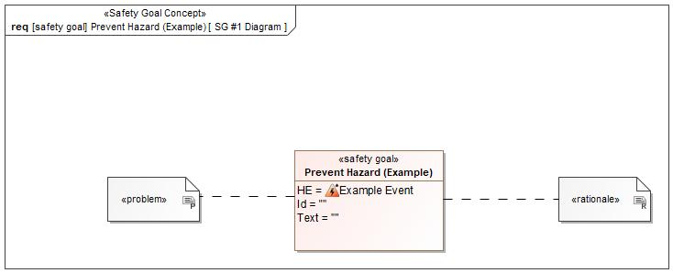

Figure 1: SG #1 Diagram – Prevent Hazard (Example)

*Note: The authoritative source for the Safety Goals is document “FFSD 02 Hazard Analysis* *and Risk Assessment”. The documentation of Safety Goals in this chapter (In the Argumentation for Safety Goal achievement) is for information purposes only.*

*The authoritative source for the Functional Safety Requirements is section 2.1.x.3: of this document. The documentation of Functional Safety Requirements in the following chapter (complete or summarised) is for information purposes only.*

#### Warning and Recovery Concept

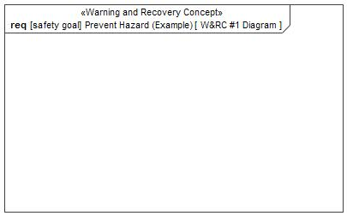

Figure 9: W&RC #1 Diagram – Prevent Hazard (Example)

#### FSRs for - Prevent Hazard (Example)

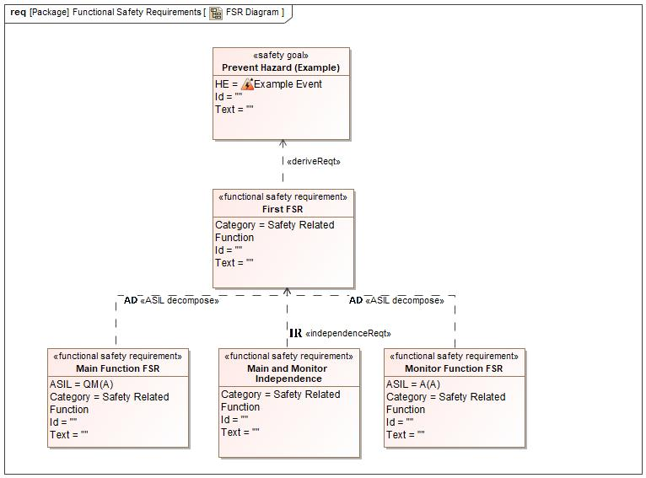

Figure 1. Prevent Hazard (Example)

First FSR

Satisfied by:

* Logicals:
  + AmbientLightingOutputManager

Related to:

* Safe States:
  + Safe State #1

|  |  |  |  |  |  |  |  |
| --- | --- | --- | --- | --- | --- | --- | --- |
| Requirement ID: | | | | | | | |
| **Purpose** |  | | | | | | |
| **V&V Acceptance Criteria** |  | | | | | | |
| **Notes** |  | | | | | | |
| **Source** |  | | | | | **Owner** |  |
| **Source Req.** | * -1314860806.jpg Prevent Hazard (Example) | | | | | **V&V Method** |  |
| **Type** | N/A | | **Priority** | | N/A | **Status** |  |
| **ASIL** |  | | **Category** | | Safety Related Function | **Fault Handling Time** | N/A |
| [Req. Template](http://wiki.ford.com/display/RequirementsEngineering/Requirements+Attributes) Version | | 6.0 | | End of Requirement | | | |

Monitor Function FSR

Related to:

* Safe States:
  + Safe State #1

|  |  |  |  |  |  |  |  |
| --- | --- | --- | --- | --- | --- | --- | --- |
| Requirement ID: | | | | | | | |
| **Purpose** |  | | | | | | |
| **V&V Acceptance Criteria** |  | | | | | | |
| **Notes** |  | | | | | | |
| **Source** |  | | | | | **Owner** |  |
| **Source Req.** | * -1314860806.jpg Prevent Hazard (Example) | | | | | **V&V Method** |  |
| **Type** | N/A | | **Priority** | | N/A | **Status** |  |
| **ASIL** | A(A) | | **Category** | | Safety Related Function | **Fault Handling Time** | N/A |
| [Req. Template](http://wiki.ford.com/display/RequirementsEngineering/Requirements+Attributes) Version | | 6.0 | | End of Requirement | | | |

Main Function FSR

Related to:

* Safe States:
  + Safe State #1

|  |  |  |  |  |  |  |  |
| --- | --- | --- | --- | --- | --- | --- | --- |
| Requirement ID: | | | | | | | |
| **Purpose** |  | | | | | | |
| **V&V Acceptance Criteria** |  | | | | | | |
| **Notes** |  | | | | | | |
| **Source** |  | | | | | **Owner** |  |
| **Source Req.** | * -1314860806.jpg Prevent Hazard (Example) | | | | | **V&V Method** |  |
| **Type** | N/A | | **Priority** | | N/A | **Status** |  |
| **ASIL** | QM(A) | | **Category** | | Safety Related Function | **Fault Handling Time** | N/A |
| [Req. Template](http://wiki.ford.com/display/RequirementsEngineering/Requirements+Attributes) Version | | 6.0 | | End of Requirement | | | |

Main and Monitor Independence

Related to:

* Safe States:
  + Safe State #1

|  |  |  |  |  |  |  |  |
| --- | --- | --- | --- | --- | --- | --- | --- |
| Requirement ID: | | | | | | | |
| **Purpose** |  | | | | | | |
| **V&V Acceptance Criteria** |  | | | | | | |
| **Notes** |  | | | | | | |
| **Source** |  | | | | | **Owner** |  |
| **Source Req.** | * -1314860806.jpg Prevent Hazard (Example) | | | | | **V&V Method** |  |
| **Type** | N/A | | **Priority** | | N/A | **Status** |  |
| **ASIL** |  | | **Category** | | Safety Related Function | **Fault Handling Time** | N/A |
| [Req. Template](http://wiki.ford.com/display/RequirementsEngineering/Requirements+Attributes) Version | | 6.0 | | End of Requirement | | | |

### Derivation of Functional Safety Requirements on Assumptions

No Functional Safety Requirements tracing to Assumptions specified.

### ASIL Decomposition of Functional Safety Requirements

#### Decomposition of Functional Safety Requirement

| Input FSR | First FSR | |
| --- | --- | --- |
| Decomposition Rationale |  | |
| Method for Decomposition | A -> A(A) + QM(A) | |
| FSR 1 after Decomposition | FSR ID |  |
| FSR Title | Monitor Function FSR |
| ASIL | A(A) |
| Rationale |  |
| Satisfied by |  |
| FSR 2 after Decomposition | FSR ID |  |
| FSR Title | Main Function FSR |
| ASIL | QM(A) |
| Rationale |  |
| Satisfied by |  |
| FSR for Independence  *Note: should consider commonly used input, output and processing*  *Note: additional row should be added if additional* *requirements for Independence are necessary* | F-S-Req.-ID |  |
| F-S-Req. Title | Main and Monitor Independence |
| ASIL |  |
| Rationale |  |

# CyberSecurity

## Security Goals

|  |  |  |
| --- | --- | --- |
| ID | Goal | |

Table 17: Cybersecurity Goals

## Cybersecurity Requirements

# Architecture

## Functional Decomposition

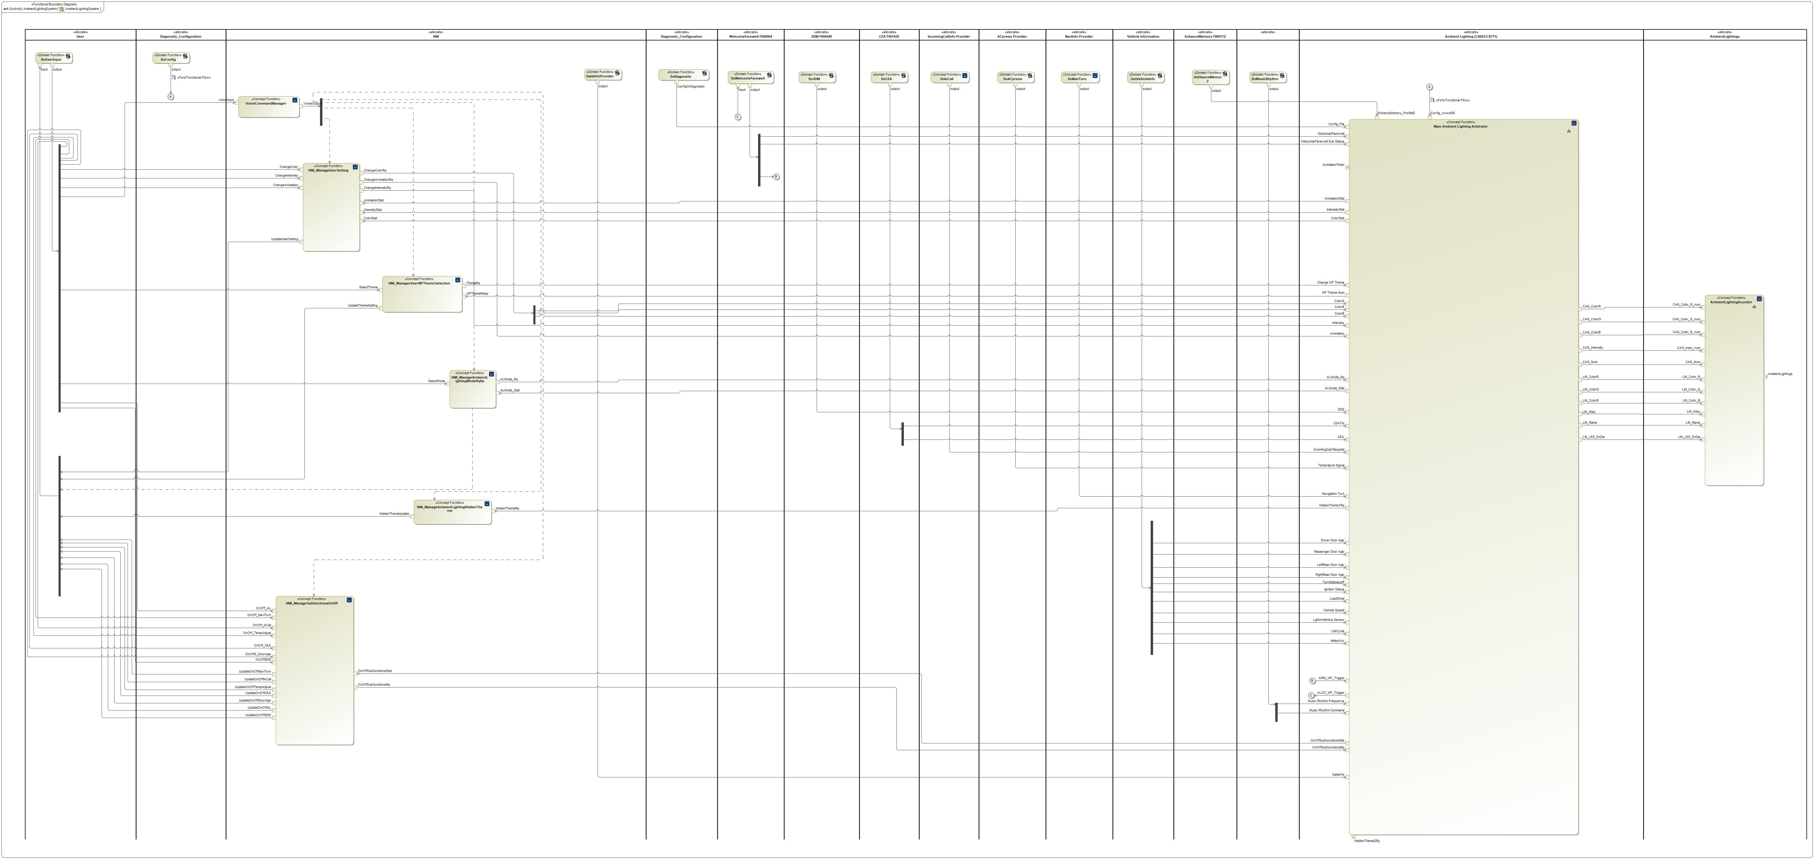

Figure 10: AmbientLightingSystem

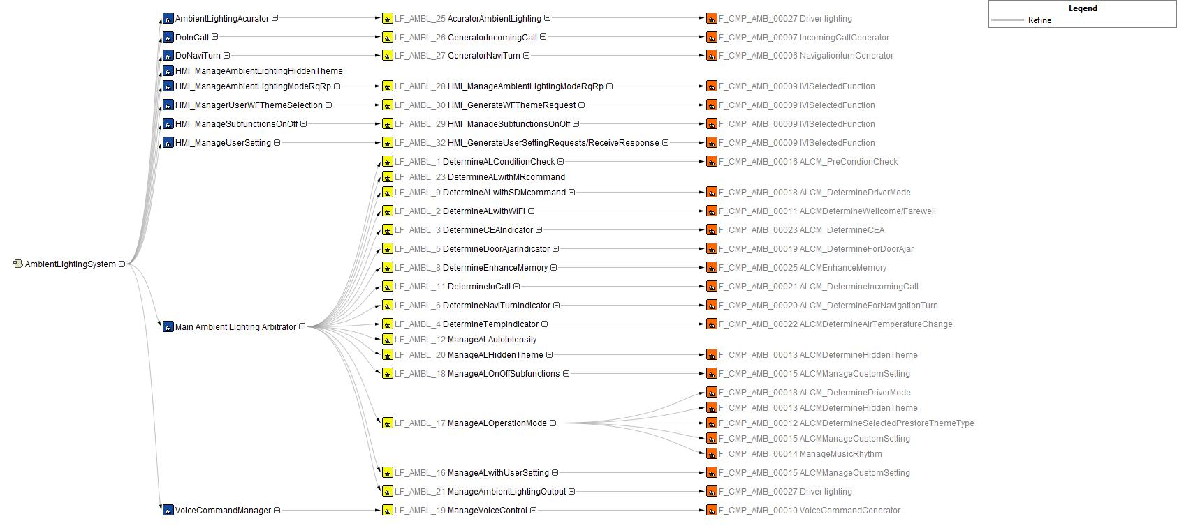

Figure 10: Functional

Decomposition

### Functions

| **Function Name** | Description | Comments |
| --- | --- | --- |
| *(activity)* HMI_ManageAmbientLightingModeRqRp | *(activity)* This the function that how HMI show ambient lighting operation mode to user. |  |
| *(activity)* GetVehicleInfo | *(activity)* This is the function to provide vehicle informations. |  |
| *(activity)* DateInfoProvider |  |  |
| *(activity)* DoInCall | *(activity)* This is the function that InComingCall feature triggers. |  |
| *(activity)* DoWelcomeFarewell | *(activity)* This is the function that WelcomeFarewell feature triggers. |  |
| *(activity)* HMI_ManageAmbientLightingHiddenTheme | *(activity)* This is the function that how HMI to sent hidden theme notification as well as choice button when hidden theme triggers. |  |
| *(activity)* DoSDM | *(activity)* This is the function that SDM feature triggers. |  |
| *(activity)* DoEhanceMemory | *(activity)* This is the function that EM feature triggers. |  |
| *(activity)* Main Ambient Lighting Arbitrator | *(activity)* This is main ambient lighting logical manager. |  |
| *(activity)* DoMusicRhythm | *(activity)* This is the function that MR feature triggers. |  |
| *(activity)* DoDiagnostic | *(activity)* This is the activity user do diagnostic. |  |
| *(activity)* HMI_ManagerUserWFThemeSelection | *(activity)* This the function that how HMI manage welcome/farewell animation chosen. |  |
| *(activity)* DoACpress | *(activity)* This is the function that AC pressing triggers. |  |
| *(activity)* DoUserInput | *(activity)* This is the function that user setting triggers. |  |
| *(activity)* HMI_ManageSubfunctionsOnOff | *(activity)* This is the function that how HMI manage user choses On and Off ambient lighting subfunctions. |  |
| *(activity)* DoNaviTurn | *(activity)* This is the function that NaviTurn feature triggers. |  |
| *(activity)* VoiceCommandManager | *(activity)* This is the function that specify voice command influence to the ambient lighting system. |  |
| *(activity)* HMI_ManageUserSetting | *(activity)* This is the function that how HMI manages ambient lighting user setting. |  |
| *(activity)* DoCEA | *(activity)* This is the function that CEA feature triggers. |  |
| *(activity)* DoConfig | *(activity)* This is the activity user do ALCM config. |  |
| *(activity)* AmbientLightingAcurator | *(activity)* This is the function group how ambient lighting system to drive ambient lightings. |  |

Table 19: List of Functions on AmbientLightingSystem

## Logical Architecture

Description of diagram and content on logical architecture in Documentation field of Structural Boundary Diagram.

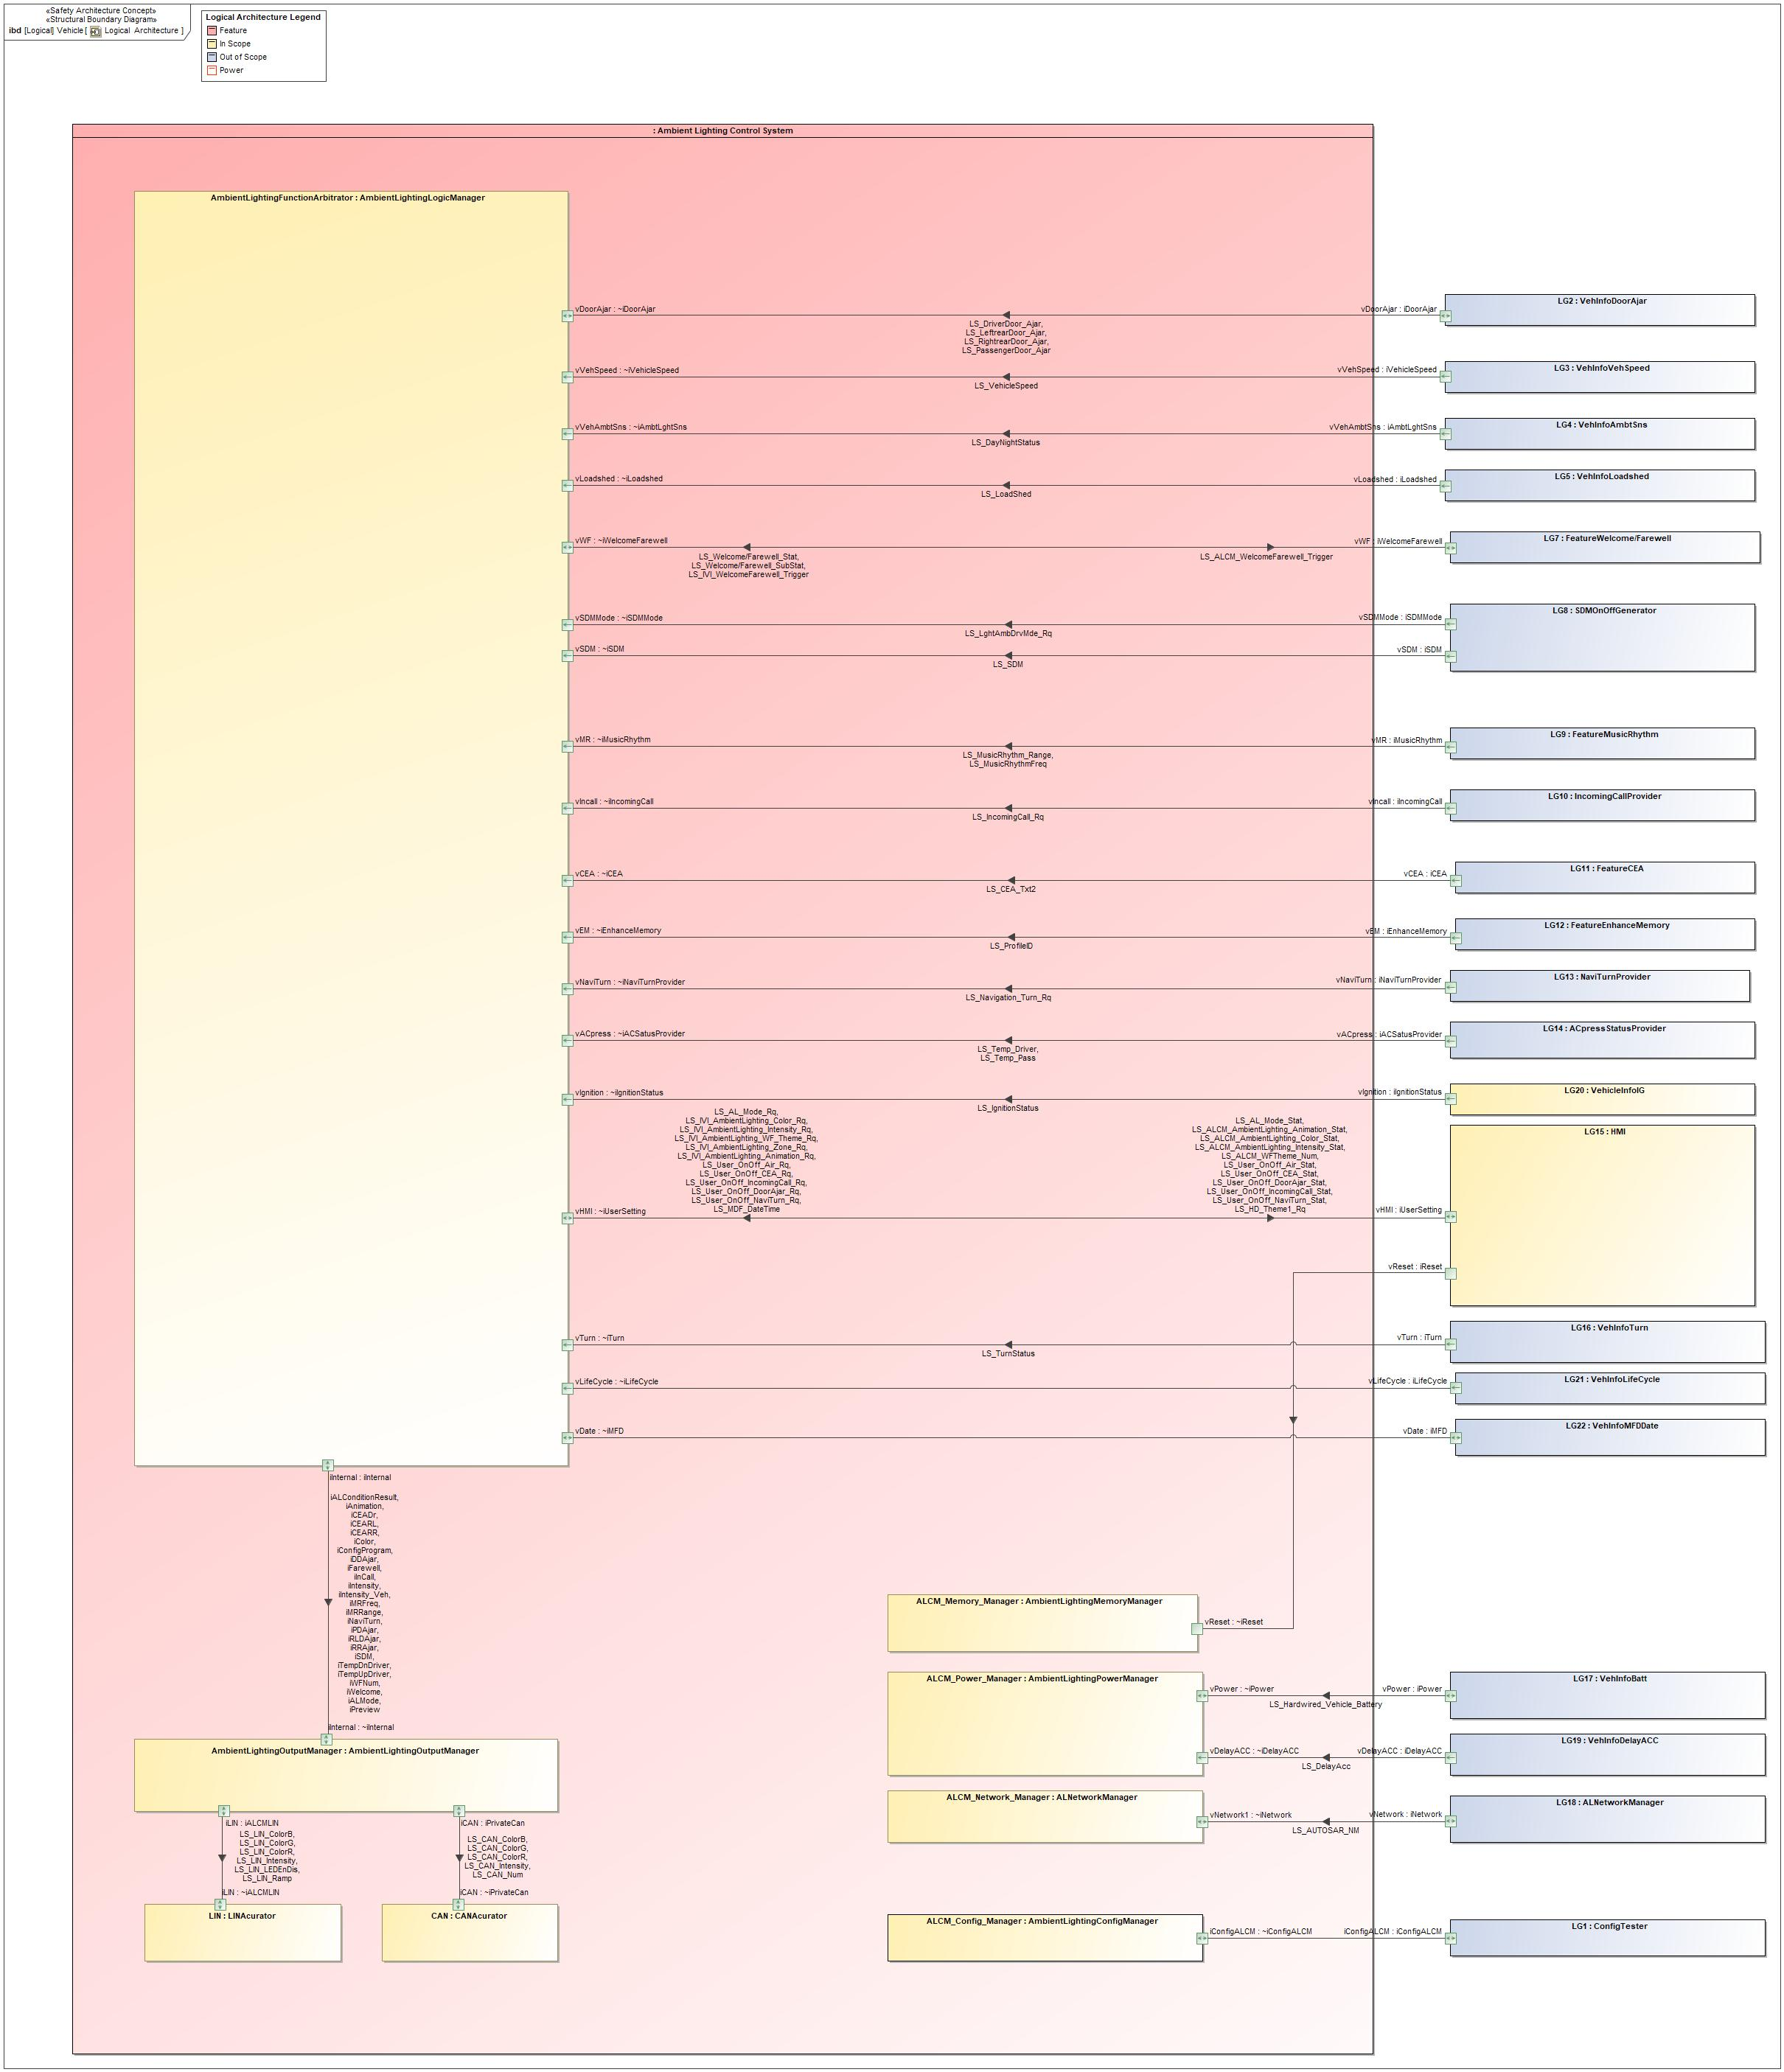

Figure 11: Logical Architecture

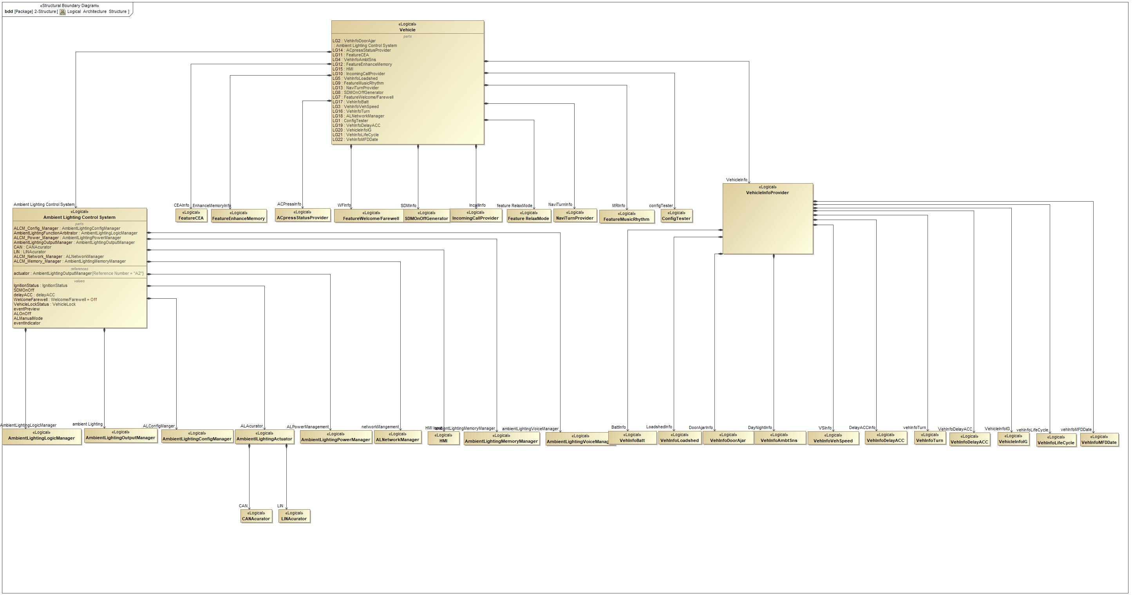

Figure 11: Logical Architecture Structure

### Logical Elements

| **Element Name** | **Description** | **Allocated Functions** | **Comments** |
| --- | --- | --- | --- |
|  |  |  |  |
| ACpressStatusProvider | A functions that provide user press AC button status. |  |  |
| ALNetworkManager | A system that make control of network wakeup and sleep. |  |  |
| Ambient Lighting Control System | A function that make a control of all ambient lighting components. | * ManageALAutoIntensity * GeneratorTempAdjust * GeneratorNaviTurn * GeneratorIncomingCall * HMI_GenerateWFThemeRequest * HMI_GenerateUserSettingRequests/ReceiveResponse * HMI_ManageAmbientLightingModeRqRp * HMI_ManageAmbientLightingSDMRq * HMI_ManageSubfunctionsOnOff * GenerateMRrq * AcuratorAmbientLighting * ManageVoiceControl * ManageALSystemPower * ManageAmbientLightingOutput * ManageMomory * DetermineCEAIndicator * DetermineDoorAjarIndicator * DetermineInCall * DetermineNaviTurnIndicator * DetermineTempIndicator * DetermineALConditionCheck * DetermineALwithMRcommand * DetermineALwithSDMcommand * ManageALwithUserSetting * DetermineALwithWlFl * DetermineEnhanceMemory * ManageALHiddenTheme * ManageALOperationMode * ManageALOnOffSubfunctions * DeterminePreview * ManageDignostic * ManageWFNum |  |
| AmbientLightingConfigManager | A system that make a control of ALCM configuration. | * ManageDignostic |  |
| AmbientLightingLogicManager | A system that make a decision of which indicator function should be turned on. | * DetermineALwithMRcommand * DetermineALwithSDMcommand * ManageALwithUserSetting * ManageALOperationMode * DetermineDoorAjarIndicator * DetermineCEAIndicator * DetermineNaviTurnIndicator * DetermineTempIndicator * DetermineInCall * ManageALOnOffSubfunctions * DetermineALConditionCheck * DetermineEnhanceMemory * DetermineALwithWlFl * ManageALHiddenTheme * Update HMI to New Selection * SaveToModuleStorage * ManageALAutoIntensity * Send IncallWithALFunction to OFF request * DeterminePreview * ManageWFNum |  |
| AmbientLightingMemoryManager |  | * ManageMomory |  |
| AmbientLightingOutputManager | A system that make control of ambient lighting on, off, color, intensity and animation. | * Domain External Function * Ideal Subfunction 4 * ManageAmbientLightingOutput |  |
| AmbientLightingPowerManager | A system that manages power on, off. | * ManageALSystemPower |  |
| AmbientLightingVoiceManager |  | * ManageVoiceControl |  |
| AmbientlLightingActuator | A system that make control of ambient lighting output. | * DriveLightings * AcuratorAmbientLighting |  |
| CANAcurator | A system that make control of ambient lighting CAN output. |  |  |
| ConfigTester |  |  |  |
| delayACC |  |  |  |
| Feature RelaxMode |  |  |  |
| FeatureCEA | A group of CEA functions. |  |  |
| FeatureEnhanceMemory | A group of Enhance Memory functions. |  |  |
| FeatureMusicRhythm | A function that provide music rhythm command. | * Domain External Function * GenerateMRrq |  |
| FeatureWelcome/Farewell | A group of welcome/farewell functions. |  |  |
| HMI | A system of HMI functions. | * Generate Signal LS_MFD_DateTime * RemindThemeUpdate and UpdateThemeSelectionTab * User Select Hidden Theme * ReceiveThemeNumFBandUpdateHMI * HMI_ManagerUserWFThemeSelection * Send IncallWithALFunction to ON request * Update IncallwithALFunction to ON * KeepNoChange * KeepNoChange * SavetoModuleStorage * Send IncallWithALFunction to OFF request * Update OnOff Indicator * Keep no change * SavetoModuleStorage * HMI_ManageAmbientLightingModeRqRp * Update Request_UserSelectMode * Do Not Update AmbientLightingModeActualSignal * Update HMI display To Enable * Send LastSaved AmbientLighting Mode( IF LastSaved AmbientLighting Mode == OFF, send value ON) * Update SDM button to Off * SavetoModuelStorage * Get LastSaved AmbientLighting Mode * Set Ambient Lighting Mode to Default:ON * Send Last Set Request * Update SDM button to On/Update AL OnOff to On * HMI_GenerateWFThemeRequest * UpdateWFThemeHMI to replied WF number * HMI_GenerateUserSettingRequests/ReceiveResponse * Update User Setting HMI * HMI_ManageSubfunctionsOnOff * HMI_ManageAmbientLightingSDMRq * HMI_ManageAmbientLightingModeRqRp * Update HMI to New Selection * ManageDignostic * GeneratorTempAdjust |  |
| IgnitionStatus |  |  |  |
| IncomingCallProvider | A function that provide incoming call status. | * GeneratorIncomingCall |  |
| LINAcurator | A system that make control of ambient lighting LIN output. |  |  |
| NaviTurnProvider | A function that provide Navigation Turn command. | * GeneratorNaviTurn |  |
| SDMOnOffGenerator | A group of function that provide SDM status. |  |  |
| Vehicle |  |  |  |
| VehicleInfoIG |  |  |  |
| VehicleInfoProvider | A group of functions that provide vehicle informations. |  |  |
| VehicleLock |  |  |  |
| VehInfoAmbtSns | A function that provide sunload sensor status. |  |  |
| VehInfoBatt | A function that provide vehicle battery. |  |  |
| VehInfoDelayACC | A function that provide delay ACC on/off status. |  |  |
| VehInfoDoorAjar | A function that provide vehicle door ajar status. |  |  |
| VehInfoLifeCycle |  |  |  |
| VehInfoLoadshed | A function that provide vehicle battery loadshed information. |  |  |
| VehInfoMFDDate |  |  |  |
| VehInfoTurn |  |  |  |
| VehInfoVehSpeed | A function that provide vehicle speed. |  |  |
| Welcome/Farewell |  |  |  |

Table 20: Logical Elements

### Logical Interfaces

# Traceability Matrix

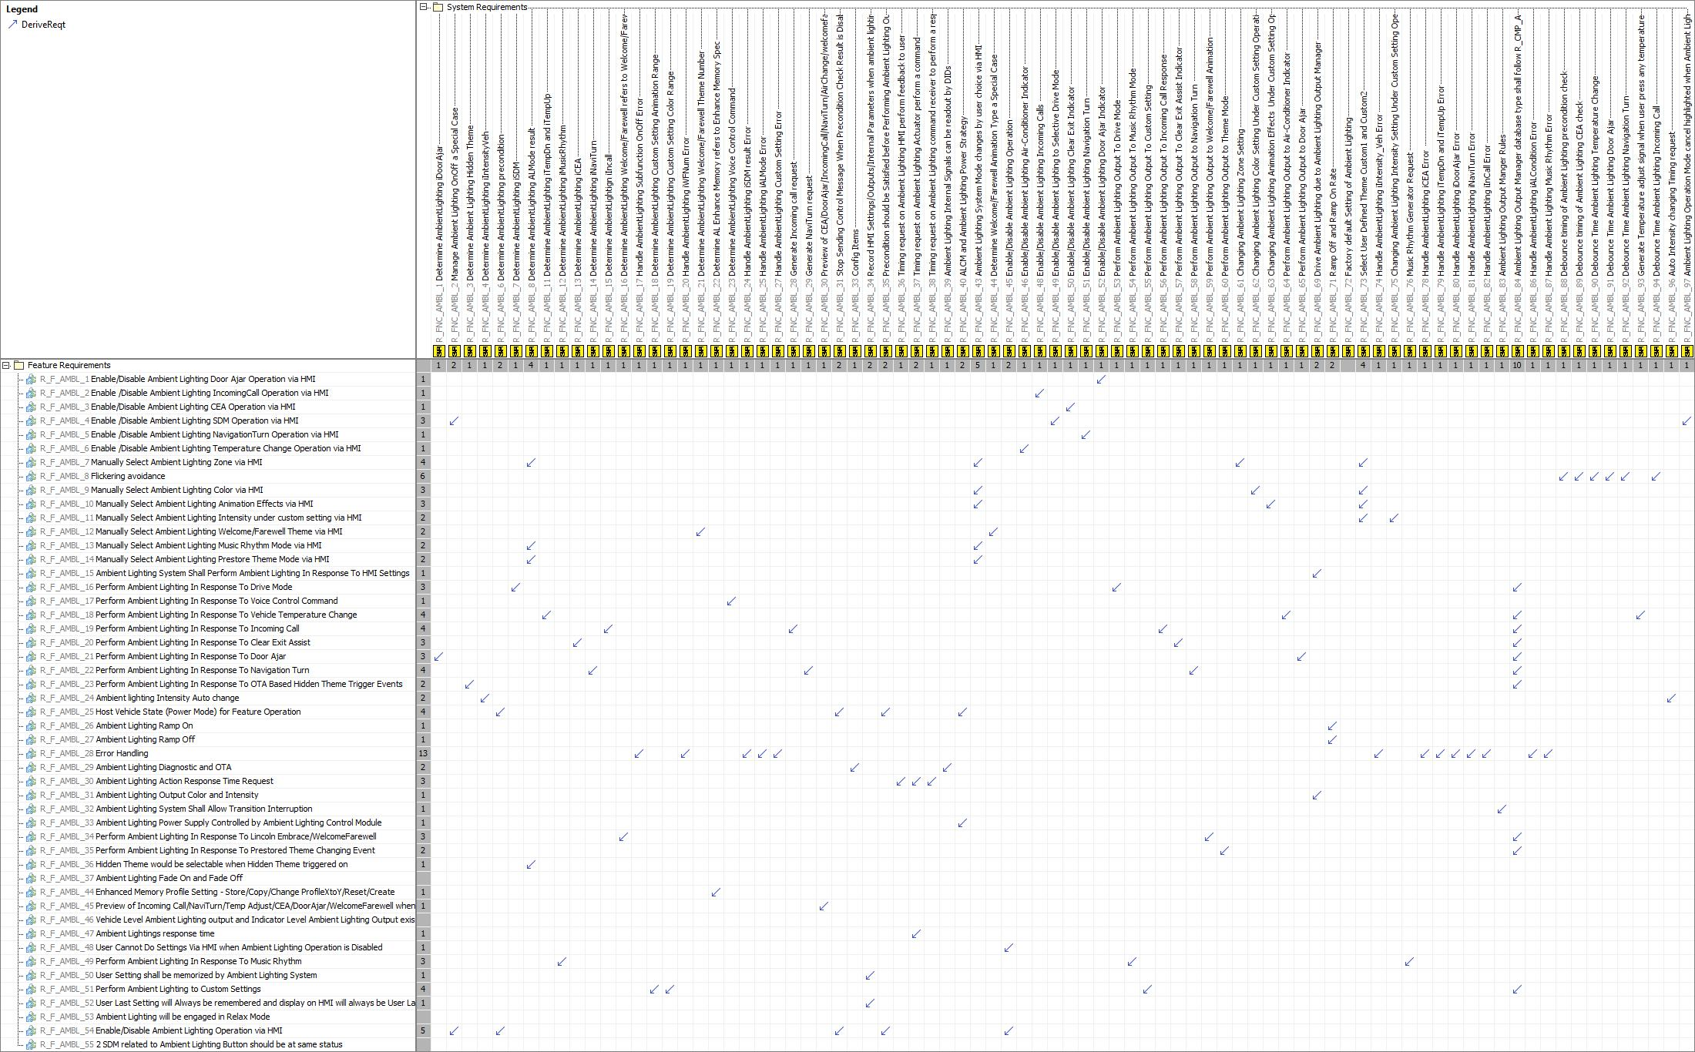

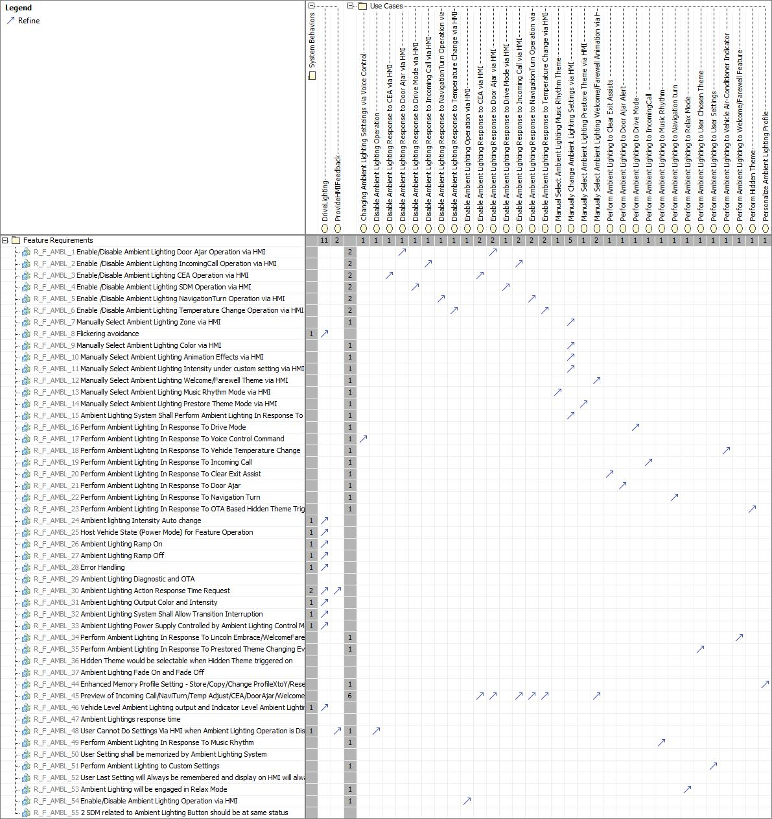

# Open Concerns

| ID | Concern Description | e-Tracker / Reference | Responsible | Status | Solution |
| --- | --- | --- | --- | --- | --- |
| 1 |  |  |  |  |  |

Table 23: Open Concerns *(Not supported by MagicDraw report generation)*

# Revision History

| Rev.  (revision) | Date | Description | Approved by | Responsible |
| --- | --- | --- | --- | --- |
| FD1 | 2022-08-18 | Document draft created from MagicDraw model |  | xyin10 |

Table 24: Revision History

## Template Revisions

|  |  |  |  |  |
| --- | --- | --- | --- | --- |
| Version | Rev. | Date | Description | Responsible |
| 0 | 6 | 2015-05-26 | * Chapter “Feature Overview” and made a 2nd level heading. * Chapter “Feature Modeling” divided into 3 subchapter (“Scenarios”, “Use Cases”, “State Machines”) for different modeling methods | Jbaden1 |
| 0 | 7 | 2015-05-27 | * Table of Content updated * Template Revision History chapter added | Jbaden1 |
| 0 | 8 | 2015-07-02 | * Section “Unsettled Issues” added | Alevin7 |
| 0 | 9 | 2015-08-04 | * Section “Feature Variants” added * Section “Feature Boundary Diagram” renamed to “Feature Context Diagram” * Document Properties adapted to match needs of VBA macros | Jbaden1, Awegman1 |
| 1 | 0 | 2015-09-11 | * Section “Feature Variants” reworked * Feature Goals removed. Only “Safety Goals“ chapter remains. * Heading 2 formatting issues corrected. * Requirements / Use Cases Listing removed from traceability chapter. * Formatting of attribute table in Notation chapter corrected * Open Topics / Known Issues chapter moved to the end | Jbaden1 |
| 1 | 1 | 2015-11-16 | * Table-Styles removed (for smooth VSEM import) * Some clean-up of sections “Purpose” and “Audience” | Awegman1, jbaden1 |
| 1 | 2 | 2016-02-26 | * Minor corrections based on lessons learned from CC and PCL pilot (e.g. section market/regions) and discussion with Functional Safety Team (purpose of feature) * Footer corrected * Boundary diagram interface chapter renamed to influences. | Jbaden1 |
| 1 | 3 | 2016-02-26 | * Minor corrections after review with Whitney Keith from Functional Safety team | Jbaden1 |
| 1 | 4 | 2016-03-10 | * Some cleanup of meta-data in Word Properties | Jbaden1 |
| 1 | 5 | 2016-03-10 | * Footer formatting corrected (Issue 19) * Results from review with Functional Safety Team incorporated (Issue 20). | jbaden1 |
| 1 | 6 | 2016-04-18 | * Scenario Template added | Jbaden1 |
| 1 | 7 | 2016-04-18 | * Chapter “Operation Modes and States” moved before “Use Case” section. | Jbaden1 |
| 1 | 8 | 2016-04-18 | * Broken Wiki links repaired. | Jbaden1 |
| 2 | 0 | 2016-05-19 | * Adapted to Specification_Macros.dotm V2.0 * Requirements Templates chapter (ch. 1.7.1) no longer has an attribute table, but refers directly to the Wiki.. | Jbaden1 |
| 2 | 1 | 2016-06-10 | * Table for Context Diagram modified (lists external entities and Influence Description only) | Jbaden1 |
| 2 | 2 | 2016-07-08 | * Template version added to footer * Several hints added to the various sections * Findings from Functional Safety Team incorporated. * RE_SafetyRequirement style added | Jbaden1 |
| 2 | 3 | 2016-09-21 | * Update from Functional Safety Team incorporated (“Lessons Learned”, “System Behaviors for HARA”) | Jbaden1 |
| 2 | 4 | 2016-11-15 | * Update from Functional Safety Team incorporated (“Lessons Learned”, “System Behaviors for HARA”) * Explanatory notes made more formal | Jbaden1 |
| 3 |  |  | Skipped to synchronize with Specification_Macros.dotm |  |
| 4 |  |
| 5 | 0 | 2017-01-13 | * Meta data updated for specification macros, version 3.1 * SW Unit chapter removed for the time being * Green boxes added for user hints | Jbaden1 |
| 5 | 1 | 2017-01-18 | * Minor editorial changes | Jbaden1 |
| 6 | 0 | 2017-02-03 | * CR48: Chapter 6 renamed from “Safety” to “Functional Safety”. New sub-chapter “Safety” introduced in Non-Functional Requirements section | Jbaden1 |
| 6 | 0 | 2017-04-28 | * CR7: “RequirementsTraceability” chapter removed | Jbaden1 |
| 6 | 0 | 2017-11-15 | * CR32/53: New Cover Sheet + Disclaimer replaces FAP-150 like ones. * CR75: Some rewording -> Terminology to Glossary, Notation -> Document Conventions * CR49: Rename “Assumptions & Constraints” to “Assumptions” * CR74: Safety Assumptions added to chapter 6. * CR58: Add function allocation column to Logical Architecture chapter | Jbaden1 |
| 6 | 0 | 2018-01-31 | * CR63: Updated links to Functional Safety Sharepoint | Jbaden1 |
| 6 | 0 | 2018-07-24 | * CR69: Add FSR to FeatureDoc * CR64: Add new section "Design Requirements" to Function Spec and Feature Spec | Jbaden1 |
| 6 | 0 | 2018-08-06 | * CR53: some corrections for metada and formatting | Jbaden1 |
| 6 | 0 | 2018-09-28 | * Broken links to RE Wiki repaired | Jbaden1 |
| 6 | 0 | 2018-10-31 | * Cover sheet and footer more GIS like. Functional Safety team feedback incorporated:   + New subsections “Functional Safety Requirements, (Decomposed) FSRs and Parameters / Values   + Removal of “Logical Architecture” | Jbaden1 |
| 6 | 0 | 2018-12-12 | * FSR template removed, now as a macro in the Specification_Macros.dotm | Jbaden1 |
| 6 | 0a | 2019-05-23 | * Re-introduce “Logical Architecture” (for Functional Safety) | Jbaden1 |
| 6 | 0b | 2019-06-26 | * Chapter “Logical Elements” in “Logical Architecture” section added (FuSa CR 15136240) | Jbaden1 |
| 6 | 0c | 2019-03-22 | * Chapter “Decomposed FSRs” renamed to “ASIL Decomposition of Functional Safety Requirements” and moved beneath Chapter “Functional Safety Requirements”. Explanatory text improved. | Jbaden1 |
| 6 | 0c | 2019-04-05 | * Some wording in ASIL decomposition table modified. Description of fields in that table improved. | Jbaden1 |
| 6 | 0c | 2019-06-24 | * “Input Requirements” section modified (table approach as for the other RE templates). * “References” and “Glossary” chapter moved to the “Introduction” chapter. | Jbaden1 |
| 6 | 0c | 2019-07-02 | * "Important" box added on cover sheet which points to the macros | Jbaden1 |
| 6 | 0c | 2019-07-02 | * Subsection “Error Handling” removed form chapter “Feature Requirements”->”Functional Requirements” (teams are free to create their own substructure of that section). Note tells author not to forget about error handling. * Hint for chapter “Feature Variants” improved reworded upon request from Functional Safety Team. | Jbaden1 |
| 6 | 0c | 2019-05-11 | * Copyright notice shortened and moved to cover sheet and added to footer (to be compliant [with Ford copyright guidelines](http://www.fgti.ford.com/client/NewFGTI/CopyrightNotice.html)) * Term “Disclaimer” no longer used for what is actually only a copyright notice | Jbaden1 |
| 6 | 0c | 2019-22-11 | * Chapter “Input Requirements/Documentst: minor modifications (examples added), Word comment removed” | Jbaden1 |
| 6 | 0c | 2019-12-05 | * Upstream Documents section added to “Input Requirements/Documents” table * Custom style table formatting removed * Hint on system behaviors modified as requested from FuSa team | Jbaden1 |
| 6 | 0c | 2019-12-09 | * Term “Upstream Documents” replaced by “Attribute Requirements” in “Input Requirements/Documents” table * ASIL Decomposition table replaced by a version, which get not corrupted during VSEM import. | Jbaden1 |
| 6 | 0c | 2019-12-10 | * In ch. “Functional Safety Requirements” Word reference Id by Word reference text replaced.. | Jbaden1 |
| 6 | 1a | 2020-02-12 | * New chapter “Cybersecurity” added. | Jbaden1 |
| 6 | 1a | 2020-03-03 | * All User Hints formatted using style “RE_UserHint” to enable automatic removal by a macro. | Jbaden1 |
| 6 | 1a | 2020-03-04 | * Chapter “Cloud Connectivity Data Analytics Requirements” added upon request by D. Crockett/J. Rawlings | Jbaden1 |
| 6 | 1a | 2020-03-09 | * Missing doc property “LatestSigMappingID” and “LatestAisInterfaceID” added * doc property “CopyrightDate” re-formatted to text and copyright date field in footer corrected * Version numbering re-initialized as 0.1 * Init value of version/revision date set to “yyyy/mm/dd” instead of “yyyy-mm-dd” to be in line with the “Edit Document Property” dialog * type of document property for latest IDs changed to number instead of text | Jbaden1 |
| 6 | 1b | 2020-03-17 | * Chapter “Functional Architecture” renamed to “Functional Decomposition” * New MBSE terminology introduced: “Feature Level”, “Function Level” and “Component Level” renamed to “Concept Level”, “Logical Level” and “Technology Level” | Jbaden1 |
| 6 | 1b | 2020-07-03 | * CR31: Chapter “Traceability Matrix” added. | Jbaden1 |
| 6 | 1b | 2020-23-09 | * CR28: Alignment to [*FFSG01.10 Feature Document Guideline*](https://azureford.sharepoint.com/sites/GlobalFunctionalSafety/Released%20Templates%20Guidelines%20and%20Examples/Guidelines/FFSG01.10_FeatureDocument_Guideline.pdf) for how to apply the Feature Doc template for Functional Safety. New section “Classification of Chapters” added. “Active Tilt Control” Example in section “Logical Architecture” updated based on input from HARA training. | Jbaden1 |
| 6 | 1b | 2020-25-11 | * Reference to process definition in Stages added to “How to Use” section on cover sheet. User hints removed from “Document Purpose” chapter. * RE-Wiki links mostly replaced by Stages links, links to Functional Safety Sharepoint updated | Jbaden1 |

# Appendix

## Definitions

| **Definition** | **Description** |
| --- | --- |
| Music Rhythm | Ambient lights rhythm with sound frequency and loudness change |

Table 25: Definitions used in this document

## Abbreviations

| **Abbr.** | **Stands for** |
| --- | --- |
| ALCM | Ambient Lighting Control Module |
| CAN | Controller Area Network |
| CEA | Clear Exit Assist |
| HMI | Human Machine Interaction |
| IVI | In-Vehicle Infotainment |
| LIN | Local Interconnect Network |
| MR | Music Music Rhythm |
| SDM | System Driver Mode |
| WF | Welcome/Farewell feature |

Table 26: Abbreviations used in this document

Document ends here.